The Immediate Impact of COVID-19 Pandemic on Tourism in Mauritius
Z. Khan Jaffur & B. Seetanah
University of Mauritius, Réduit, Mauritius
DRAFT
Abstract
This study assesses the initial impact of the COVID-19 pandemic on tourist arrivals for Mauritius. It provides interesting COVID-19 and tourism statistics for Mauritius in the first place, and preliminary analysis of the monthly time series data (tourist arrivals) confirmed that the series departed from their original trends after the outbreak of COVID-19: observed values were lower than those predicted by the selected optimal forecast model. The CausalImpact methodology was subsequently used to estimate the impact of COVID-19 on the island’s tourism market during the first quarter of 2020 (January 2020-March 2020). The findings indicated that the COVID-19 had a statistically significant and negative effect on Mauritius during the first quarter of 2020.

Introduction
The world has been struck by several pandemics episodes in its history including the Spanish flu in 1918, followed by the Asian influenza in 1957 and the Hong Kong flu in 1968 amongst others. This century has already gone through the 2002-04 severe acute respiratory syndrome coronavirus (SARS-CoV) outbreak and more recently the 2009 H1N1 swine flu pandemic.
Identified in December 2019, the novel coronavirus (COVID-19), which is associated with respiratory illness, began in Wuhan, the capital city of Hubei province in China, and spread very quickly from Wuhan to the whole country during the Spring Festival of 2020 and subsequently all around the world. On 30 January 2020, the World Health Organization (WHO) declared the COVID-19’s outbreak an international public health emergency and officially a pandemic on 11 March 2020. Official figures (WHO) reveal that world-wide contaminated cases hiked from 14500 (304 deaths) since 01 February 2020 to 91000 (3000 deaths) on 01 March 2020 quickly spreading to over 1 million by 01 April 2020 (49500 deaths), 3.36 million (242700 deaths) by 01 May 2020, 6.33 million by 01 June 2020 (385000 deaths). It crossed the 10 million cases by 01 July 2020 (524000 deaths) and more recent figures, as at 20 August 2020, reveal that the number of cases is over 22.56 million (over 790000 deaths). These statistics reflect how contagious the disease is and human to human transmission is a worrisome element according to the WHO. Scientists have made it a priority and spare no effort, often internationally collaborating, to come out with a vaccine, but as at date, there has been no vaccine officially approved for this disease, although clinical tests are underway for some alternatives.
While this novel coronavirus (COVID-19) is creating much health uncertainties, hitting all the economies globally and exacerbating the volatility of financial markets, the COVID-19 pandemic is feared by all socio-economic actors of the globe and is particularly turning out to be the greatest test that the modern travel industry has ever encountered (The Wall Street Journal, 24 March 2020). Travel and tourism remain among the most affected sectors with aeroplanes grounded, hotels closed and travel restrictions set up in virtually all countries around the world. The pandemic is expected to put a sudden end to a period of 10 years sustained growth since the 2007-09 financial crisis. The WTTC (2020) has pointed out a double-digit decrease of around 22% in 2020Q1, with arrivals in March down by 57% globally. This implies a loss of 67 million international arrivals, translating to over an estimated 80 billion USD in receipts for this quarter. More recent estimates in July reveals that the figures may have cost US$320 billion and three times the losses to tourism incurred as a result of the 2007-09 financial crisis (DPA, 2020). Even if earlier this year the WTTC has already declared that international travel is predicted to be negatively impacted by over 25%, an equivalent to 3 months travel, this year, leading to an estimated 12-14% reduction in jobs in the global tourism sector, however, prospects for the year have been downgraded several times since then because of the high level of uncertainty. Current scenarios point to declines of 58% to 78% in international tourist arrivals for the year (equivalent to as much as over a trillion USD loss in export revenue from tourism), depending on the speed of the containment and the duration of travel restrictions and shutdown of borders, although the outlook remains highly uncertain (UNWTO, 2020).
Island economies are countries which are economically most dependent on tourism, and they are well-known for their common characteristics: small domestic markets, a low degree of export diversification and remoteness. It is without a doubt that these countries remain quite vulnerable to external shocks and are among the most impacted by the COVID-19 pandemic. It is anticipated that the economic blow to Small Island Developing States (SIDS) will be quite severe, probably registering record drops in tourism arrivals, revenue losses and economic downturn.
This study thus assesses the immediate impact of the COVID-19 pandemic on tourist arrivals for Mauritius. The country has been quite hit by the pandemic (refer to Table A2 in the appendix concerning key COVID statistics related to total cases and the number of deaths), in addition to feeling an even greater impact with respect to tourist arrivals due to the travel fear instilled globally as well as lockdowns and travel restrictions in both these islands and from the main tourist origin countries. Table A2 in the appendix shows the trends on tourist arrivals pre and post COVID and it can be observed that there is a sharp drop in arrivals as compared to the same period in the previous year (and also compared to the previous months before the pandemic). To analyse the immediate impact of COVID-19 on tourist arrivals, we have employed the recently developed methodology of Bayesian structural time-series (BSTS) framework for causal analysis. The latter was first proposed by Brodersen et al. (2015) and relies on the implementation of the CausalImpact package in R. As the name suggests, the BSTS model is used mostly for the analysis of structural time series (see Perles-Ribes et al., 2019). Despite its origin dates back in the mid-eighteenth century, it is now widely used in the fields of philosophy, statistics, engineering as well as econometrics, particularly with the enhancement of equipment that enables a greater computing capacity (Gelman et al., 2013). The principal uses of the technique are the short-term and long-term predictions of time series and inferring causal impact, consistent with the aim of this study. Based on the availability of data, we have used ‘the total number of international tourist arrivals’ time-series data, for our analysis. The data consists of 75 monthly observations from the respective island time-series ranging from January 2014 to March 2020.
The rest of the paper is organised as follows, section 2 details the methodology while section 3 dwells into the analysis and discusses the results while section 4 concludes.

Methodology
Without doubt, impact measures can be used to inform strategic decision making and hence, help in developing appropriate and necessary policy responses. As such, evaluating the immediate impact of the outbreak of the COVID-19 pandemic on economies, states and societies is crucial at a time where most countries around the globe are facing an unprecedented crisis and perhaps the biggest economic turmoil since the Second World War. Indeed, understanding its impact on the tourism sector of any particular country is of utmost importance as this sector remains one of the economic sectors which has been mostly affected by this pandemic due to travel bans and restrictions in view to prevent the virus from spreading.
In this section, we empirically examine the immediate impact of the outbreak of the COVID-19 pandemic on Mauritius using monthly data covering the period January 2014 to March 2020, amounting to a total of 75 observations. Besides the limitations on data availability, the reasons for choosing this specific timeframe are twofold. First, January 2014 is selected as the initial period to isolate the effect of the COVID-19 pandemic from any structural changes that took place in the tourism sector due to the global financial crisis 2007-08. Second, in an attempt to better capture the effect of the pandemic on the number of tourist arrivals and to have a significant post-intervention period, we include the latest available data (i.e. March 2020)^{1, 2}. Moreover, despite that our sample size is relatively small, it is adapted to the recommendations of Brodersen (2016) on the application of Bayesian structural time-series (BSTS) models for causal analysis³, which stipulates that the length of the pre-intervention period should be approximately two or three times that of the post-intervention period whenever the impact of an intervention variable is examined on another variable. Accordingly, the breakpoint is set to December 2019 (Observation 72) when the outbreak of COVID-19 was first declared in Wuhan, China. This, thus, leaves us with a total of 3 observations (January 2020-March 2020) for the post-intervention period (see Figure 1). Data on the total number of international tourist arrivals were extracted from Statistics of Mauritius.
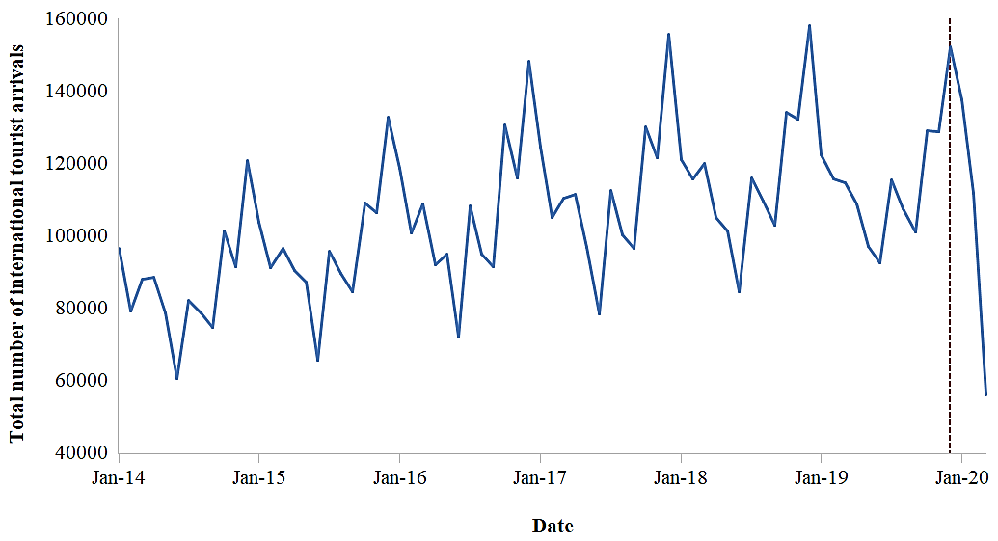
Figure 1. Overview of the total number of international tourist arrivals in Mauritius (January 2014-March 2020).
Note: Dotted lines represent the month (December 2019) in which the COVID-19 outbreak was first declared in Wuhan, China.
Source: Statistics of Mauritius.
It is clear from Figure 1 that the island experienced a sharp dip in the number of international tourist arrivals following the outbreak of the COVID-19 pandemic. An in-depth analysis of the data (see Table 1) shows how the number of international tourist arrivals declines considerably after the outbreak reaching the lowest level in March 2020, whereby most countries started to close their borders to international visitors (see Table A3 in the appendix for more details) and aeroplanes were grounded.
Table 1. Total number of international tourist arrivals for period January-March 2019/20.
 | January |  | February |  | March |  | January-March |  | % Decrease
Country/Year | 2019 | 2020 | 2019 | 2020 | 2019 | 2020 | 2019 | 2020 | 2019-2020
Mauritius | 122273 | 137419 | 115613 | 111560 | 114419 | 55863 | 352305 | 304842 | 13.5
Bahamas | 636881 | 687200 | 608371 | 711699 | 749044 | 302118 | 1994296 | 1701017 | 14.7
Jamaica | 465535 | 436363 | 422876 | 409721 | 448151 | 177318 | 1336562 | 1023402 | 23.4
Maldives | 151552 | 173347 | 168583 | 149788 | 162843 | 59627 | 482978 | 382762 | 20.7
Seychelles | 29463 | 32731 | 36807 | 38114 | 35244 | 18067 | 101514 | 88912 | 12.4
Singapore | 1630000 | 1690000 | 1500000 | 732760 | 1570000 | 239900 | 4700000 | 2662660 | 43.3
Source: Authors’ elaboration.
In the same vein as Perles-Ribes et al. (2018, 2019a, 2019b), we follow a two-step procedure to apply the BSTS framework for causal analysis. In the first instance, we perform single time series analysis using the autoregressive integrated moving average (ARIMA) models to have a visual inspection of the impact of the outbreak of the COVID-19 pandemic on the number of international tourist arrivals and to determine a suitable country that can be used as a synthetic control for the causal analysis. This also allows us to check whether these countries are affected by the outbreak or not or any structural changes.
For this purpose, we consider the time series of the countries in Table 1 including Mauritius, and split each series into two: we use the first 72 observations in the pre-intervention period (January 2014-December 2019) to estimate an optimal model based on ARIMA framework and employ the latter to forecast the remaining 3 observations in the post-intervention period (January 2020-March 2020)⁴. The country whose real values and predicted ones match closely is considered as a suitable synthetic control. It should be noted that the most appropriate control is the one which has been less affected by the outbreak of the COVID-19 pandemic or any structural change.
The second step involves estimating the impact of the outbreak of the pandemic on the number of international tourist arrivals for Mauritius together by controlling for the country identified in the first step using the methodology proposed by Brodersen et al. (2015). As highlighted previously, the intervention variable refers to the outbreak of the COVID-19 pandemic and it was officially declared in December 2019, we, thus, use data up until December 2019 to create the counterfactual scenarios, and data between January 2020 and March 2020 are employed to estimate the impact. In line with previous empirical research on BSTS framework for causal analysis (see, for instance, Perles-Ribes et al. 2018, 2019a, 2019b; Soto-Valero and Pic, 2019), the static regression technique is favoured to reduce any overfitting problems.

Results
In this section, we present the results obtained upon applying the two-step procedure discussed previously. Figure 2 and Figure 3 illustrate the results obtained from the single time-series analysis based on the ARIMA framework. In general, it can be observed from these figures that the series departed from its original trend after the outbreak of the COVID-19 pandemic: the observed (real) values were below those predicted by the optimal ARIMA models.
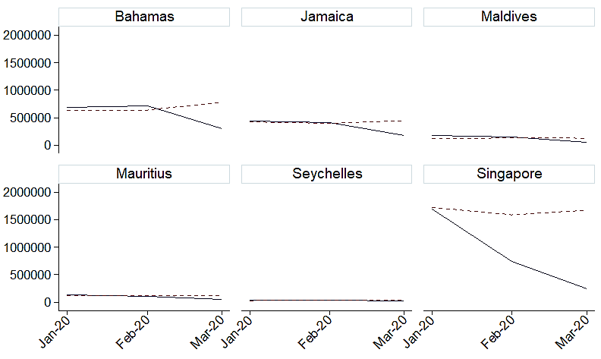
Figure 2. Selected SIDS countries, predicted and real number of tourist arrivals January 2020-March 2020.
Notes: ARIMA models; solid lines represent original values and dotted lines predicted ones; total number of tourist arrivals on y-axis and date on x-axis.
Source: Authors’ elaboration.
In other words, the figures depict a fall in the respective sector with the largest disparity in February 2020 and March 2020. This also confirms the analysis presented in Table 1. From Figure 2, it can be observed that for the period January 2020-March 2020, the real and predicted values for Seychelles match closely. As such, Seychelles is employed as synthetic control for our analysis.
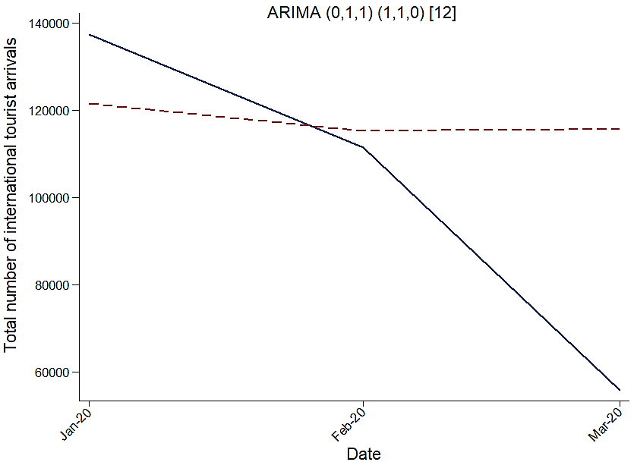

Figure 3. Predicted and real number of international tourist arrivals January 2020-March 2020.
Notes: Selected optimal ARIMA model above; solid lines represent original values and dotted lines predicted ones.
Source: Authors’ elaboration.
Table 2 summarizes the impact of the COVID-19 outbreak on Mauritius (and some selected SIDS countries) based on the monthly forecasts and the values of each series for the period January 2020-March 2020 using ARIMA models. A glance at the results indicates that all countries were negatively affected by the COVID-19 outbreak.
Table 2. Predicted and real number of international tourist arrivals: January 2020-March 2020. ARIMA models.
Country | Predicted tourist arrivals  (Jan 2020 - Mar 2020) | Tourist arrivals  (Jan 2020 - Mar 2020) |  | Absolute effect | Relative effect
Bahamas | 686476 |  | 567006 | -119471 | -14%
Jamaica | 424874 |  | 341134 | -83740 | -20%
Maldives | 130155 |  | 127587 | -2568 | -2%
Mauritius | 117559 |  | 101614 | -15945 | -14%
Seychelles | 31640 |  | 29637 | -2003 | -6%
Singapore | 1660094 |  | 887553 | -772541 | -47%
Note: Average tourist arrivals for the period January 2020-March 2020.
Source: Authors’ elaboration.
After an analysis of the time-series using ARIMA models, we interpret the results of the estimations of the impact of the outbreak of the COVID-19 pandemic on the number of international tourist arrivals starting from January 2020 using the methodology proposed by Brodersen et al. (2015). In particular, we report the results for the whole post-intervention period (January 2020-March 2020) when Seychelles is used as the control variable. Table 3 displays a breakdown of the results of both the average and cumulative impacts of the outbreak. Similar to the results illustrated based on the ARIMA framework (see Table 2), both the average and cumulative models disclose a negative coefficient for the absolute and relative effects, thereby suggesting a negative relationship between the outbreak and the number of international tourist arrivals. As can be seen from Table 3, for Mauritius for which the effect proves to be significant, the posterior probability of a causal effect ranges is 98.82%: implying that the outbreak had a greater influence on the number of international tourist arrivals in the country. This also points out that the tourism sector will be eventually mostly influenced by the measures taken to mitigate the spread of the virus in the coming months.
Table 3. Estimated impact of the COVID-19 pandemic on the total number of international tourist arrivals: January 2020-March 2020.
Country |  | Average | Cumulative
Mauritius | Actual | 100000 | 300000
 | Prediction (S.D.) | 113853 (5257) | 341560 (15771)
 | 95% confidence interval | [103335, 124141] | [310005, 372424]
 | Absolute effect (S.D.) | -12239 (5257) | -36718 (15771)
 | 95% confidence interval | [-22527, -1721] | [-67582, -5163]
 | Relative effect (S.D.) | -11% (4.6%) | -11% (4.6%)
 | 95% confidence interval | [-20%, -1.5%] | [-20%, -1.5%]
 | Posterior tail-area probability | 0.0118**
 | Posterior probability of a causal effect | 98.82%
Notes: Analysis using the CausalImpact (Brodersen et al., 2015) with Seychelles as control; Standard deviations in parentheses; 95% confidence intervals in square brackets; ***, **, * represent significance at the 1%, 5% and 10% respectively.
Source: Authors’ elaboration.
During the period following the outbreak (January 2020-March 2020), Mauritius encountered a decline in its tourism sector. On average, some 100000 foreigners visited the country. In the absence of the outbreak, this would have been 110000 in number. Thus, representing on average an absolute decrease of 12000 in tourist arrivals. Similarly, for the whole period of investigation, the results also reveal that the number of tourist arrivals experienced an absolute decrease of 36000. In relative terms, this shows a decrease of 11% in the total number of international tourist arrivals. In other words, despite that the country is far from the epicentre of the coronavirus (i.e. China), the outbreak indeed caused a statistical reduction in the number of people visiting the country (p-value = 0.0118). On the other hand, it can be seen from Table 3 that the posterior probability of a causal effect is 98.82%. This means that the country’s tourism sector will be more affected by the containment measures taken to fight the spread of the virus in the coming months. This decline in the tourism sector can be explained by the fact that the country started to admit passengers coming from Asian countries (China, South Korea and Japan) to quarantine centres since January 2020, right at the beginning of the declaration of the outbreak in China. This somehow caused a reduction in the number of tourists coming from China and South Korea, which are usually among the top ten tourism markets of the country. The effect is more visible in March 2020 (see Figure 3) whereby the government extended its travel ban to the European Union and closed its border to foreigners from 19 March 2020.
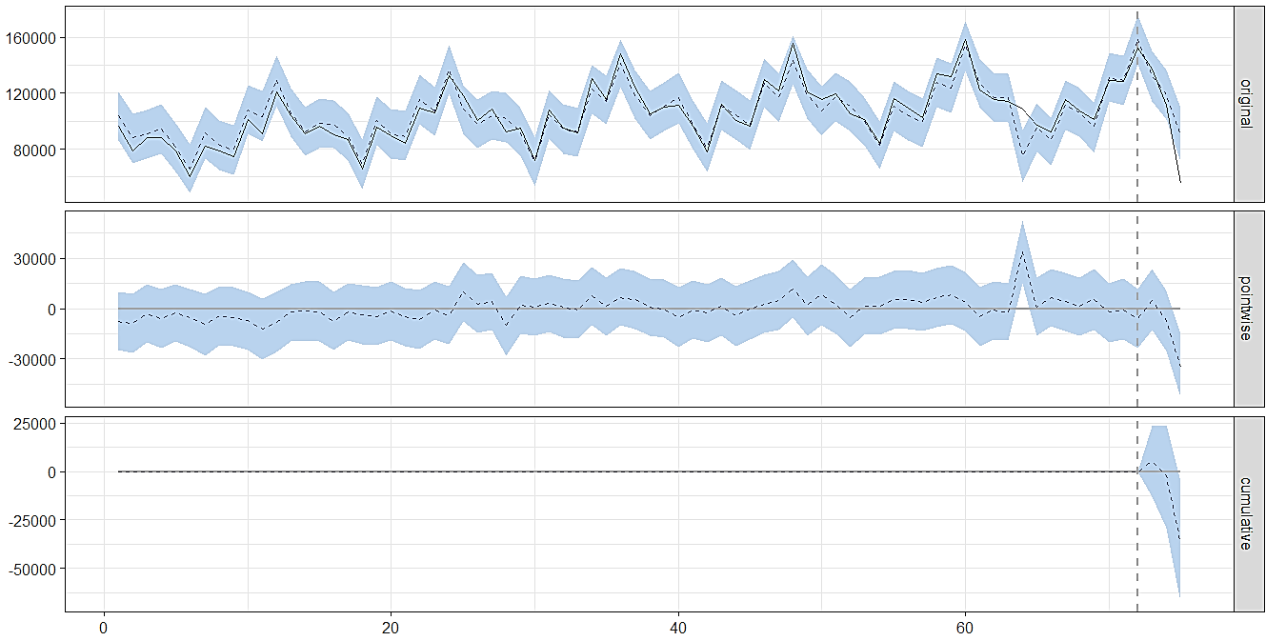
Figure 4. Impact of COVID-19 pandemic on Mauritius controlled for Seychelles.
Notes: y-axis: Total number of international tourist arrivals; Dotted vertical line representing the month in which the COVID-19 outbreak was first identified in Wuhan, China (December 2019 - Observation 73 on the x-axis); Top plot showing the observed series (black) and its predicted values (dotted blue); Middle plot showing the difference between the prediction and the observed values; Bottom plot showing the total effect of these differences within the post-intervention period.
Source: CausalImpact R-package output.

Conclusions
This study sets out to assess the initial impact of the COVID-19 pandemic on tourism arrivals for Mauritius. Preliminary analysis of the monthly time series data (tourist arrivals) confirmed that the series departed from its original trend after the outbreak of COVID-19: observed values were lower than those predicted by the selected optimal ARIMA model. The CausalImpact methodology was subsequently used to estimate the impact of COVID-19 on the island’s tourism market during the first quarter of 2020 (January 2020-March 2020). The findings indicated that the COVID-19 had a statistically significant and negative effect on Mauritius during the first quarter of 2020. It is noteworthy that the situation has since April 2020 deteriorated following the global lockdown and travel restrictions, and the final impact on tourism and the economy is yet to be known. In the context of the largest global economic recession since the great depression of the 1930s, several daunting challenges remain ahead of these economies with the unknown duration of the pandemic and travel restrictions.
Nevertheless, this study also has some limitations. First, it focused only on the number of international tourist arrivals, and the timeframe used in our sample relied upon data availability. Secondly, the results are highly dependent upon the synthetic control/covariate employed; in our case, we employed the country which was less affected by the pandemic.
As far as policy responses are concerned, in the short-term, social protection (for instance protecting workers through wage assistance schemes and other subsidies) and maintaining a healthy tourism industry remain crucial. Government continue to assist tourism enterprises in difficulty through financial relief related to low-interest loans or grants. In the medium and longer terms, governments should support economic diversification where possible while trying to boost the overall resilience of the tourism sector.

Notes
- In our case, the intervention variable refers to the outbreak of the COVID-19 pandemic and the intervention period is the month in which the latter was first declared in Wuhan, China (i.e. December 2019).
- The pre-intervention period represents the months before the declaration of the outbreak of the pandemic in Wuhan, China (i.e. January 2014-December 2019) and the remaining months (January 2020-March 2020) form the post-intervention period.
- See Brodersen et al. (2015) and Perles-Ribes et al. (2018) for an in-depth explanation of this methodology.
- This is done using the automated procedures of the forecast package of R (Hyndman and Khandakar 2008).

References
Brodersen, K., 2016. How long should the period be? Available from: https://stats.stackexchange.co/questions/128775/is-it-okay-to-run-causalimpact-in-r-on-successive-portions-of-a-time-series [Accessed 15 October 2019].
Brodersen, K.H., Gallusser, F., Koehler, J., Remy, N. and Scott, S.L., 2015. Inferring causal impact using Bayesian structural time-series models. The Annals of Applied Statistics, 9(1), 247-274.
DPA, 2020. Safe travel is already possible, UN tourism agency says, and faults governments for not doing ‘everything they can to get people travelling again’. South China Morning Post, 19 August. Available at: https://www.scmp.com/lifestyle/travel-leisure/article/3097960/safe-travel-already-possible-un-tourism-agency-says-and [accessed 10 September 2020].
Gelman, A., Carlin, J. B., Stern, H. S., Dunson, D. B., Vehtari, A. and Rubin, D. B., 2013. Bayesian data analysis. Third edition. Boca Raton, FL: CRC Press.
Hyndman, R.J. and Khandakar, Y., 2008. Automatic time series forecasting: The forecast package for R. Journal of Statistical Software, 26(3), 1-22.
Perles-Ribes, J.F., Ramón-Rodríguez, A.B. and Ortuño Padilla, A., 2019b. Brexit announcement: Immediate impact on British tourism in Spain. Cornell Hospitality Quarterly, 60(2), 97-103.
Perles-Ribes, J.F., Ramón-Rodríguez, A.B., Moreno-Izquierdo, L. and Torregrosa Martí, M.T., 2018. Winners and losers in the Arab uprisings: a Mediterranean tourism perspective. Current issues in Tourism, 21(16), 1810-1829.
Perles-Ribes, J.F., Ramón-Rodríguez, A.B., Such-Devesa, M.J. and Moreno-Izquierdo, L., 2019a. Effects of political instability in consolidated destinations: The case of Catalonia (Spain). Tourism Management, 70, 134-139.
Soto-Valero, C. and Pic, M., 2019. Assessing the causal impact of the 3-point per victory scoring system in the competitive balance of LaLiga. International Journal of Computer Science in Sport, 18(3), 69-88.
UNWTO, 2020. IMPACT ASSESSMENT OF THE COVID-19 OUTBREAK ON INTERNATIONAL TOURISM. UNWTO, May. Available at: https://www.unwto.org/impact-assessment-of-the-covid-19-outbreak-on-international-tourism [accessed 10 September 2020].

Appendix
Table A1: Monthly Tourism arrivals Jan 2019-Jun 2020
Date | Mauritius | Singapore | Seychelles | Maldives | Bahamas | Jamaica
Oct-19 | 129018 | 1530000 | 35960 | 14198 | 482676 | 275398
Nov-19 | 128730 | 1533000 | 34511 | 137921 | 618841 | 328919
Dec-19 | 152098 | 1720000 | 38910 | 171348 | 710151 | 487391
Jan-20 | 137410 | 1690000 | 32731 | 173347 | 687200 | 436363
Feb-20 | 111560 | 577742 | 38114 | 149788 | 711699 | 409721
Mar20 | 55863 | 190589 | 18067 | 59627 | 302118 | 177318
Apr-20 | 10 | 4781 | 22 | 0 | na | na
May20 | 20 | 3630 | 73 | na | na | na
Jun-20 | 9 | 4298 | 140 | na | na | na
Note: “na” stands for not available at the time of collection.
Source: www.ceicdata.com; respective national statistics office.

Table A2: Key COVID and Tourism Statistics
 | Singapore | Seychelles | Maldives | Bahamas | Jamaica | Mauritius
COVID Statistics
Population | 5855309 | 98413 | 541526 | 393687 | 2962584
Corona cases* | 55104 | 126 | 5041 | 945 | 1003
Recovered* | 18915 | 125 | 2804 | 113 | 745
Cases per million* | 9411 | 1280 | 9309 | 2401 | 339
Death * | 27 | - | 19 | 15 | 13
Death per million of pop* | 5 | - | 35 | 38 | 4
Total test* | 1,474,372 | na | 88,392 | 6557 | 42964
Total test per million* | 251801 | na | 163228 | 16657 | 14502
# of doctors per 000 (2017) | 2.1 | 0.95 | 4.6 | 2 | 1.32
# of hospital bed per 000 | 2.4 | 3.6 | 4.3 | 3 | 1.7
Tourism Statistics
Tourism arrivals (2019) | 19.11 | 0.384 | 1.5 | 7.2 | 4.3
Direct Contribution of T & T to GDP | 4 | 18 | 25 | 23.3 | 12
Total Contribution | 11.1 | 40.5 | 57 | 43.3 | 31
Direct Contribution to employment (%) | 5.5 | 19.1 | 26 | 32 | 11.4
Total Contribution to Employment (%) | 14 | 43.8 | 59.6 | 50.2 | 32.8
Note: *As at July 2020; “na” stands for not available at the time of collection.
Source: *Worldometer (https://www.worldometers.info/coronavirus/); Other figures are based on World Development Indicators (latest available statistics).

Table A3. First reported case and closure of borders
Country | 1st case reported | Borders closed
Bahamas | 15 March 2020 | 27 March 2020
Jamaica | 10 March 2020 | 21 March 2020
Maldives | 07 March 2020 | 27 March 2020
Mauritius | 18 March 2020 | 19 March 2020
Seychelles | 14 March 2020 | 08 April 2020
Singapore | 23 January 2020 | 24 March 2020
Note: Reported is the date on which the first case of COVID-19 was reported and the borders were closed to international visitors in the respective country.
Source: Authors’ compilations from respective national statistics offices.

