**SIEL 2025 Biennial Conference Held at NTU:   
Navigating New Horizons in a Changing World of International Economic Law**

The Asian Center for WTO & International Health Law and Policy (ACWH) at National Taiwan University (NTU) co-hosted the Ninth Biennial Global Conference of the Society of International Economic Law (SIEL) at NTU from July 9 to 11, 2025.

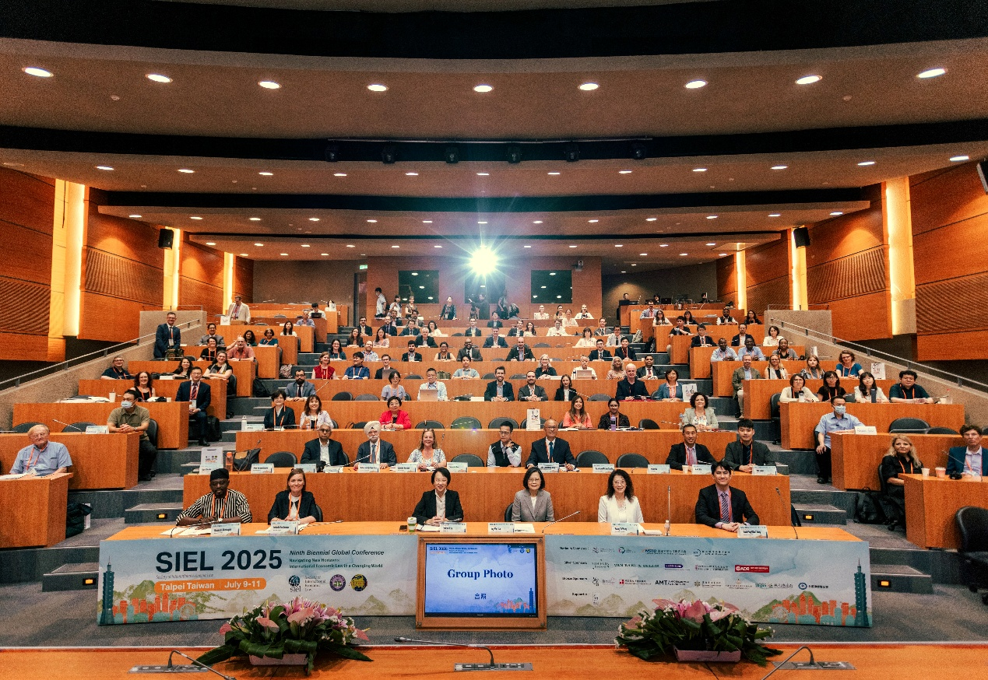

The conference’s theme was *“Navigating New Horizons: International Economic Law in a Changing World,”* focusing on how escalating geopolitical tensions, environmental challenges, economic nationalism, digital transformations, and widening inequalities are reshaping economies and societies worldwide. Prof. Locknie Hsu, President of SIEL, and Prof. Huang-Yu Wang, Dean of NTU College of Law, opened the conference, followed by a keynote address delivered by Dr. Ing-Wen Tsai, Former President of Taiwan.

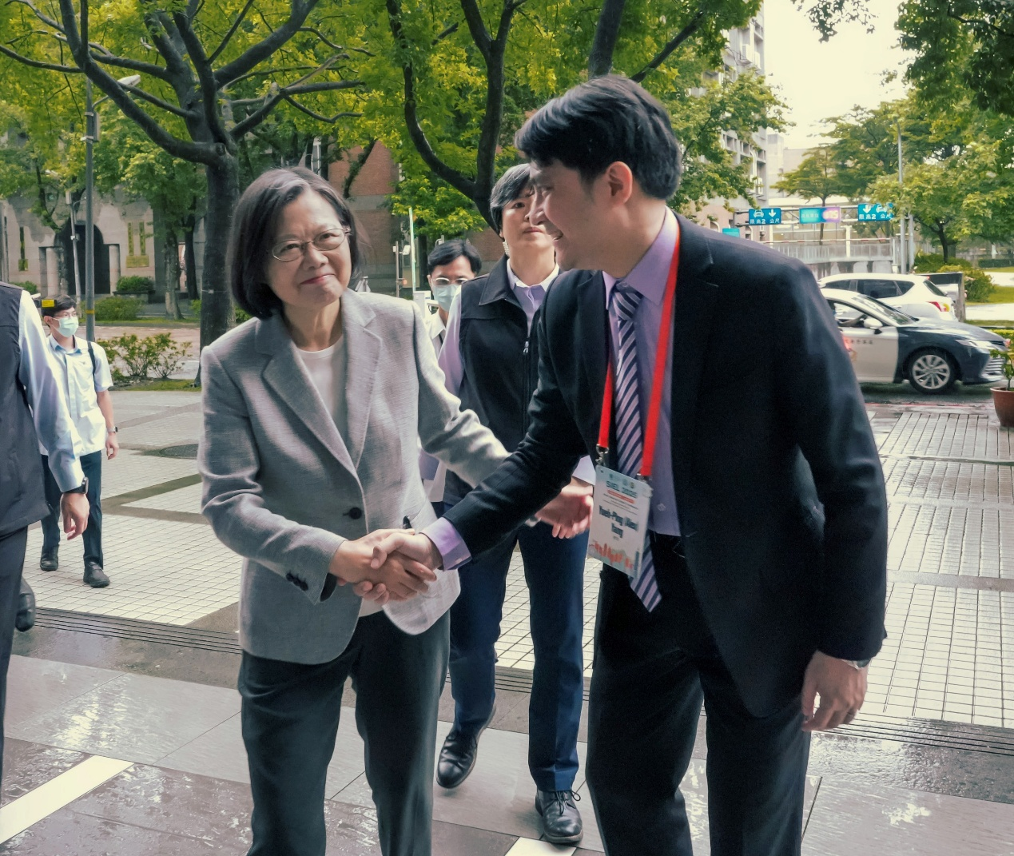

On the first day of the conference, Prof. Gregory Shaffer delivered a lecture titled *“International Economic Law and the Rule of Law,”* setting the tone for the discussions that followed. On the second day, Prof. José Manuel Alvarez Zarate presented *“Talking to Robert Hudec about International Economic Law Today,”* focusing on the interplay of power and law. Finally, on the last day, Ambassador Ujal Singh Bhatia, Prof. Thomas Cottier, and Prof. Gabrielle Marceau concluded the three-day discussion with *“A Conversation about International Economic Law in a Changing World: Lessons from the Past to the Benefit of the Future.”*

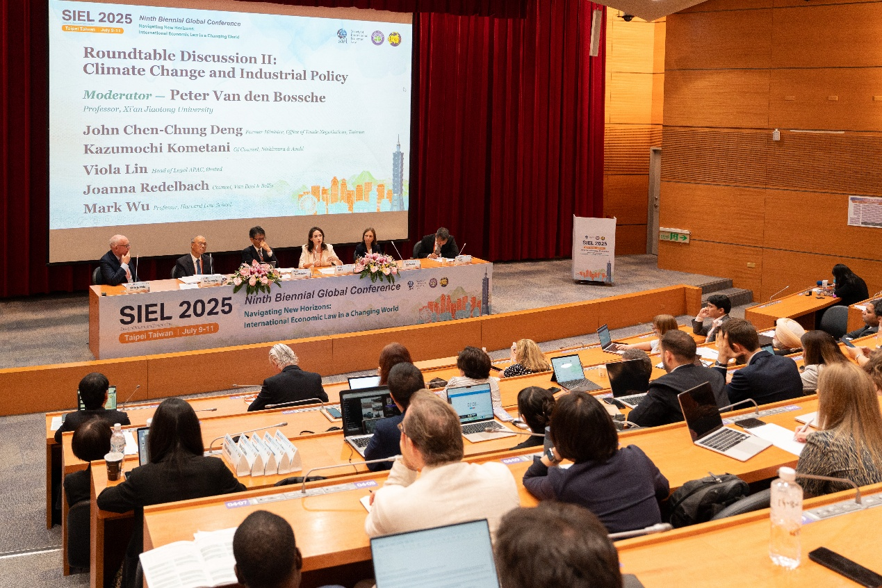

The conference featured four roundtable discussions, focusing on topics such as“Trade in Semi-Conductors,” “Climate Change and Industrial Policy,” “Investment and Sustainability,” and “International Economic Law and Technologies,” along with 28 panel sessions covering a broader range of issues. In these sessions, experienced and young academics, government officials, and industry practitioners shared their insights and engaged in in-depth discussions on pressing issues in international economic law. Key figures from Taiwan including John Chen-Chung Deng, former Minister of the Office of Trade Negotiations; Wen-Chen Shih, Deputy Minister of the Ministry of Environment; Ya-Lun Yen, Commissioner of the Fair Trade Commission; Nicholas Liao, Head and Senior Counsel for the Taiwan Region at Hon Hai Technology Group; and Viola Lin, Head of Legal APAC at Ørsted, just to name a few. These dynamic exchanges underscored the diversity of perspectives and the vibrant intellectual engagement that embodied the conference’s underlying theme.

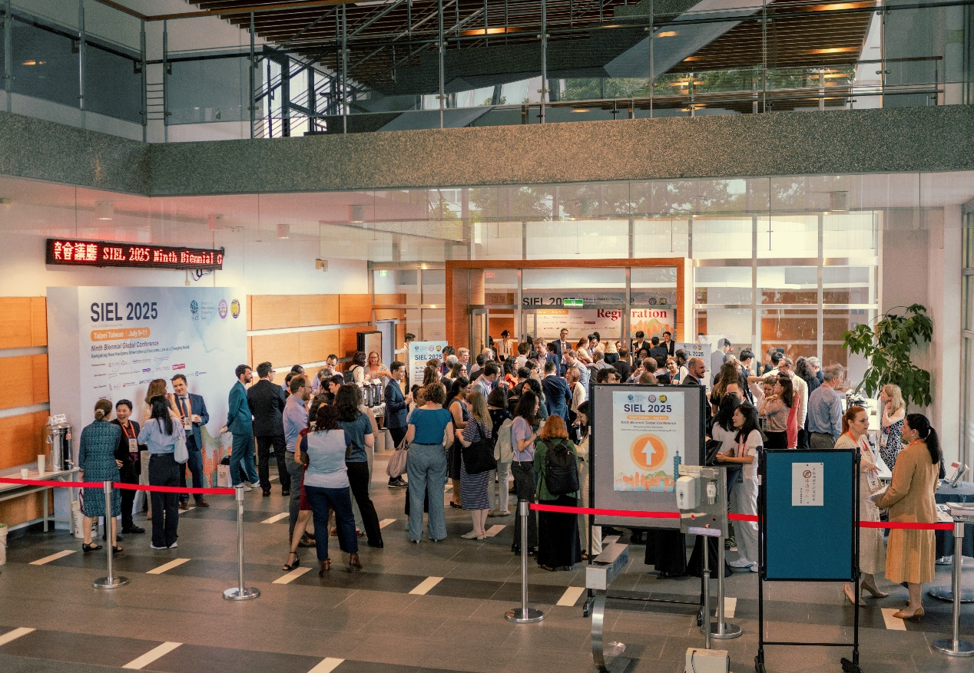

In addition, at the breakfast meetings, side events, poster sessions, and evening receptions and dinners held throughout the three-day conference, participants from diverse regions, including early-career scholars, had the opportunity to strengthen their connections and lay the groundwork for future academic dialogue. Notably, the Conference also hosted a side event on Collaborating Between and with WTO Chairs co-organized with the WTO Chairs Programme.

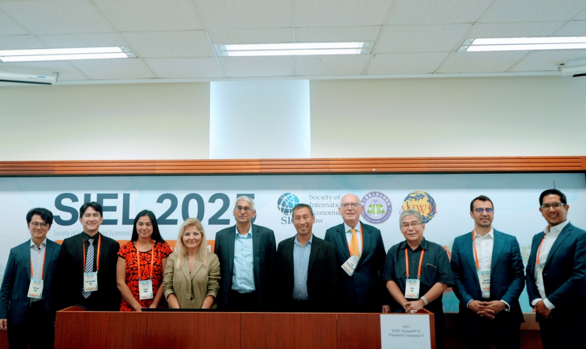

Finally, in the closing remarks, Prof. Isabelle Van Damme, SIEL’s Executive Vice-President, expressed sincere gratitude to ACWH and its team for their exceptional efforts in hosting the 2025 Biennial Conference at NTU. Prof. Olabisi D. Akinkugbe, also SIEL’s Executive Vice-President, highlighted the importance of convening regional networks and encouraged members to stay connected beyond the event. Prof. Yueh-Ping (Alex) Yang, ACWH’s Director and the local host of the Conference, expressed deep appreciation for the opportunity to host the conference and reaffirmed NTU’s and ACWH’s commitment to supporting international academic collaboration and welcoming future engagements.

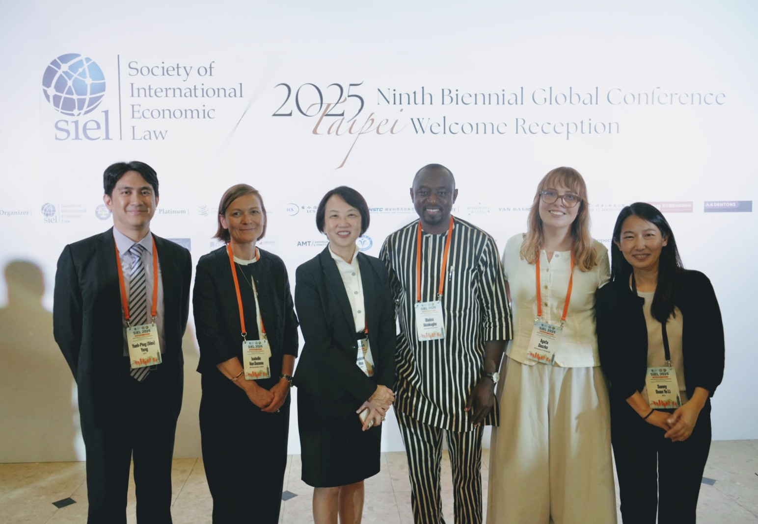

The SIEL 2025 Ninth Biennial Global Conference concluded on a high note, marking a successful and inspiring gathering of the international community of experts in international economic law.