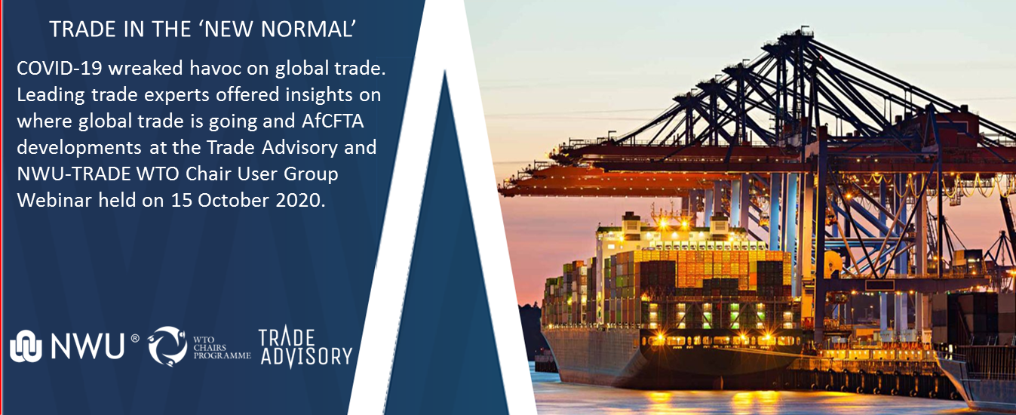

**Summary of proceedings:**   
‘Trade Advisory and NWU-TRADE WTO Chair User Group Webinar (15 October 2020)’

As COVID-19 wreaked havoc on global trade, Martin Cameron (Managing Director of [Trade Research Advisory](http://www.tradeadvisory.co.za/), a spin-out company of the [North-West University](http://www.nwu.ac.za/trade)) and Prof Wilma Viviers (Research professor) in the [TRADE](http://commerce.nwu.ac.za/trade) (Trade and Development) research entity and holder of the WTO Chair at the North-West University, South Africa hosted the 8th [TRADE-DSM](http://tradeadvisory.co.za/methodology/) User Group Webinar under the auspices of the WTO Chairs programme.

The main focus of the session was to bring leading trade experts and their insights on where global trade is going as well as the status of the AfCFTA and the digital trade development and opportunities in Africa to our audience.

One of the main consequences of Covid-19 is the unprecedented level of uncertainty that has been unleashed throughout the world in all spheres - economic, commercial, political and social. The World Trade Organization ([WTO](https://www.wto.org/)) predicts that the global economy will see a relatively slow recovery in the short term, which is unlikely to return trade to its pre-pandemic trend any time soon.

“International trade performance will be an important determinant of how quickly and how well economies recover from the pandemic,” said Dr Alexander Keck from the WTO’s Global Economic Analysis section, the keynote speaker at the webinar. He added that although the WTO expected all regions to see a significant contraction in their exports and imports in 2020, trade would bounce back in 2021 - albeit still below pre-Covid-19 levels.

“As countries adapt to a post-Covid era, there will be much greater emphasis placed on digital cross-border trade, diversification of supply chain sourcing, and more autonomous and flexible forms of production.” Alexander cautioned, though, that trade flows would remain vulnerable to weaker consumer demand, lacklustre investment and high trade costs.

“The advent of Covid-19 as well as the financial crisis more than a decade ago shows how vulnerable African countries are to external shocks,” said Komi Tsowou of [UNCTAD](https://unctad.org/)’s Africa and Least Developed Countries Division, who was also speaking at the webinar. He said that the African Continental Free Trade Area (AfCFTA) represented an excellent opportunity for African countries - which have long been fragmented and overly dependent on commodities - to unleash their untapped economic potential by reducing or removing tariffs and non-tariff barriers.

“In creating a large, consolidated market, the AfCFTA will lead to greater economies of scale and lower business costs, which are among the keys to competitiveness on the continent.” Of course, the AfCFTA needs more than simply enthusiasm on the part of Africa’s leaders to deliver positive results and true value. It requires getting the basics right, such as reliable electricity and water, and decent transport infrastructure, while also focusing on effective implementation.  
  
John Stuart, a [tralac](https://www.tralac.org/) associate, spoke encouragingly of the progress that Africa has made in recent years in adopting digital technologies to catch up with the rest of the world and boost economic and trade activity on the continent.

“The digital economy is the economy,” he said, adding that as the continent went into lockdown in the face of Covid-19, digital trade and e-commerce grew noticeably. “Africa is playing catch up and making progress in closing the digital divide as it is the last continent in which a large proportion of the population is still offline, due to the high cost of access and a lack of technical know-how.”

African start-ups like Jumia and MallforAfrica, which operate e-commerce platforms, are making names for themselves and extending trade across borders in ways that would previously not have been possible. John said that e-commerce is helping to address several of Africa’s trade-related constraints by, for example, reducing transport costs, improving access to markets, streamlining the regulatory process and facilitating access to international value chains.

“But developing a strong and extensive e-commerce culture on the continent means that critical constraints need to be addressed: high broadband costs, a lack of funding, a low penetration rate and dependence on foreign owners of e-commerce platforms”.   
  
Martin Cameron of Trade Advisory stressed that logistics problems were particularly serious constraints to trade growth and diversification in Africa because they made it difficult for exporters and importers to take advantage of identified trade opportunities. He commented that the real challenge for Africa and the potential benefits of the AfCFTA for the African continent will be determined by real world logistics and infrastructure, and while aspects such as harmonisation of tariffs are necessary, this dimension has the least impact when compared to access to finance, logistics and infrastructure.

In summarising the webinar proceedings, Prof Raymond Parsons of the North-West University [Business School](http://commerce.nwu.ac.za/business-school) remarked that globalisation clearly needs to work better. “If it does not, poorer countries will find it increasingly difficult to catch up and richer countries will become more expensive and less free.” He also spoke of the importance of the world operating under a rules-based system which has the power to reduce uncertainty. Africa has an opportunity to emerge from the Covid-19 crisis into a better ‘new normal’, but there needs to be stronger commitment to implementation of policies and plans, characterised by political will and more involvement by the private sector in solving Africa’s problems.

**For more information about:**

Trade Research Advisory, contact Martin Cameron ([martin.cameron@tradeadvisory.co.za](mailto:martin.cameron@tradeadvisory.co.za))   
or

the NWU-TRADE WTO Chair programme, Prof Wilma Viviers ([wilma.viviers@nwu.ac.za](mailto:wilma.viviers@nwu.ac.za))

The [TRADE-DSM](http://tradeadvisory.co.za/methodology/) is recognised by leading international organisations as a reputable and scientific methodology aimed at trade facilitation that assists exporters, export promotion organisations and governments with complex market selection activities and decisions.

Presentations and recording of the webinar is available at:

<http://tradeadvisory.co.za/resources/>

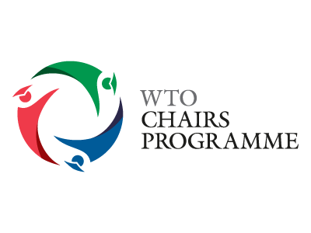A picture containing clipart

Description generated with very high confidence