Effect of Brexit Referendum: The case of Mauritius-UK Trade
Khan-Jaffur Z and Seetanah B.
University of Mauritius, Réduit, Mauritius
Corresponding author. Email: b.seetanah@uom.ac.mu
Abstract
For years, the United Kingdom (UK) has been one of the top export destinations for Mauritius. The Brexit referendum, held in June 2016, not only affected the UK economy but also resulted in several economic repercussions worldwide, including Mauritius. To this end, this article aims at investigating the impact of the Brexit referendum on the Mauritius-UK trade sector. In particular, we examine its potential impact on the Mauritius-UK export market during the post-Brexit referendum period (2016Q3-2019Q4) using the recently developed Bayesian structural time-series models. The results show that Mauritius-UK export market was indeed negatively impacted by the Brexit referendum. Nevertheless, this was not due to the fluctuations in the bilateral exchange rate (Rs/GBP). Our findings suggest reinforcing existing trade policies and closely monitor the new bilateral trade agreement with the UK.
Keywords: Brexit; Mauritius-UK; Export market.

- Introduction
The June 2016 referendum held in the United Kingdom in relation to whether it should stay in the European Union (EU) results in a marginal vote favouring a Brexit. The British government formally announced UK’s withdrawal on 29th March 2017 and triggered the so called Brexit process. However, the withdrawal was delayed following a deadlock in the British parliament, but following the subsequent general election, the withdrawal agreement was eventually ratified by the Parliament and the UK left the EU on 31 January 2020. This initiated a transition period that is set to end on 31 December 2020, a period during which both parties are meant to negotiate their future relationship. Theoretically speaking such a disintegration is expected to, at least in the short term, lead to uncertainties which could ultimately translate into reduced domestic and inward foreign investment, trade, currency depreciations and ultimately economic growth. Indeed, Brexit started to have some impacts since its announcement itself. For instance, on the announcement day itself, as the results of the referendum spread around, the pound sterling depreciated significantly with respect to the Euro and the US Dollar (Allen et al., 2016). The International Monetary Fund (2016) announced a downward review (between 1% and 2%) of the economic growth projections for the United Kingdom. The Brexit referendum, held in June 2016, not only affected the UK economy but also resulted in several economic and sector repercussions worldwide.

This short article focuses on the immediate impact of the Brexit referendum on Mauritian export to the UK. It is noteworthy that in the present case, the immediate impact is understood as that arising from the result of the Brexit vote. It includes the process activation related to the notification of the British government to the Commission with respect its withdrawal from the EU. The potential impact on Mauritian trade could be due to the uncertainties surrounding the Brexit, mainly through exchange rate changes but as well through reduced growth prospects in UK. It is noteworthy that following the Brexit announcement in late June 2016, the GBP (vis a vis the Rupee) depreciated by around 7% in the following month, reaching 11% in December 2016 and reached around 12.5 depreciation as at July 2019. Since then a slight appreciation of the GBP has been recorded.

It is noteworthy that UK used to be our main export market for the two decades after independence, with a share of nearly 70% in the 1970’s and 80’s, mainly due to our colonial ties and also heavy export of textiles and sugar under some preferential trade agreement. With the gradual dismantling of such preferences and Mauritius embarking in its export diversification process, the share of export to UK has fallen steadily and reached 36% in 1990’s, 30% in 2000’s and 22% in the 2010’s. Despite this continuous fall in the share of export to UK, currently the United Kingdom (UK) is still Mauritius’ top export market with around 11.2% (2019), closely followed by United States (10.7%), South Africa (10.4%), France (10%), Madagascar (7%), Italy (5.5%), Spain (4%), Netherlands (4%) and Germany (2%).
Given UK’s crucial importance in Mauritius international trade and economy in general, this research focuses on the impact of the Brexit referendum on the Mauritius-UK export market for the period 2016Q3-2019Q4. To uncover this, we have employed the recent methodology, proposed by Brodersen et al. (2015), which relies on the implementation of the CausalImpact package in R within a Bayesian structural time-series model setting for causal analysis. Bayesian structural time series are those used to approach the analysis of structural time series (see Perles-Ribes et al., 2019). Bayesian methods are now widely used in the fields of philosophy, statistics, engineering as well as econometrics, particularly with the enhancement of equipment that enable a greater computing capacity (Gelman et al., 2013). The principal uses of the technique are the short-term and long-term prediction of time series and inferring causal impact, consistent with the philosophy of this article.
The remainder of this article is organised as follows. Section 2 describes the methodology used. The next section presents and discusses the empirical results and the last section concludes.

- Data and Methods
To examine the impact of the Brexit referendum on the Mauritius-UK export market, quarterly data for the 2009-2019 period (44 observations) are used. The choice of this specific timeframe is two-fold. First, the first quarter of 2009 (2009Q1) is selected as the initial period to isolate the Brexit referendum effect from any potential structural changes that took place in the respective export market due to the global financial crisis 2007-08. Second, in an attempt to better capture the effect of the Brexit referendum on the UK export market in Mauritius and to have a significant post-intervention period, we include the latest available data (i.e. 2019Q4). It is worth noting that despite our sample size is small, it is adapted to the recommendations of Brodersen (2016) on the application of Bayesian structural time-series models for causal analysis: “the length of the pre-intervention period should be approximately two or three times that of the post-intervention period whenever the impact of an intervention variable (in our case Brexit referendum) is examined on another variable”. Accordingly, the breakpoint is set to 2016Q2 (Observation 30) when the Brexit referendum took place, and this leaves us with a total of 14 observations (2016Q3-2019Q4) for the post-intervention period (see Figure 1). Data on exports is extracted from Statistics of Mauritius and bilateral exchange rate (Rs/GBP) from Bank of Mauritius.
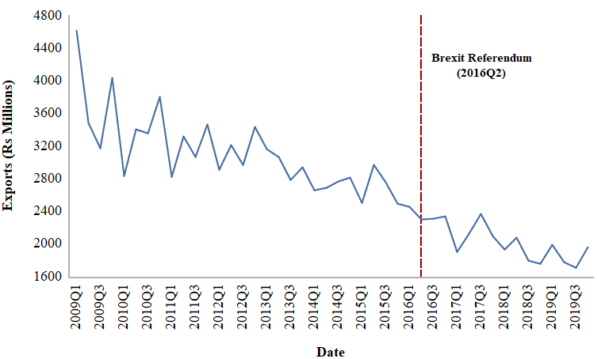
Figure 1. Overview of Mauritius-UK Export Market.
Source: Statistics Mauritius (2020).
In a similar spirit as Perles-Ribes et al. (2018, 2019a, 2019b), we follow a two-step procedure to apply the Bayesian structural time-series model framework for causal analysis. In the first instance, we perform single time series analysis using the autoregressive integrated moving average (ARIMA) models to have a visual inspection of the impact of the Brexit referendum on the Mauritius-UK export market and to determine a suitable country that can be used as a control for the causal analysis. This also allows us to check whether these countries are also affected by the Brexit referendum or any other structural changes. Any country which is found to be affected by the event (i.e. the Brexit referendum) or any structural change is discarded as a potential control in the next step.
For this purpose, we consider two other main export markets of Mauritius namely the United States and France. For each series, the first 30 observations in the pre-intervention period (2009Q1-2016Q2) are used for the estimation of an optimal model based on ARIMA framework. This optimum model is then employed to forecast the remaining 14 observations in the post-intervention period (2016Q3-2019Q4). The country whose real values and predicted ones match closely is considered as a suitable control. It should be noted that the most appropriate control is the one which has not been affected by any structural change.
The second step involves estimating the impact of the Brexit referendum on the Mauritius-UK export market controlling for the country identified in the first step using the above-mentioned methodology, proposed by Brodersen et al. (2015). As highlighted previously, the intervention variable refers to the Brexit referendum and it occurred in the second quarter of 2016 (2016Q2), we, thus, use data up until 2016Q2 to create the counterfactual scenario and the remaining observations (2016Q3-2019Q4) are used to estimate the impact. One question that arises is whether this decline in the Mauritius-UK export market is due to the depreciation of the Pound Sterling (GBP) in the international market after the announcement of the Brexit. To this end, we also employ both the static and dynamic regression techniques to examine the effect of the bilateral exchange rate (Rs/GBP) on the respective export market. In other words, we regress the respective export market against the bilateral exchange rate (Rs/GBP).
- Results
Figures 2-4 illustrate the results obtained from the single time-series analysis based on the ARIMA framework. It can be seen that an ARIMA (3, 1, 0) with drift is selected for the Mauritius-UK export market. In other words, the optimal model for this particular series is a three-order autoregressive model with an order of integration of one. We then employ this model to provide forecasts for the post-intervention period (2016Q3-2019Q4). Figure 2 depicts a fall in the respective export market following the Brexit referendum. A closer look at the predictions obtained shows that the series departs from its original trend after the Brexit referendum (see Figure 3). In general, the observed values are below those predicted by the optimal model.
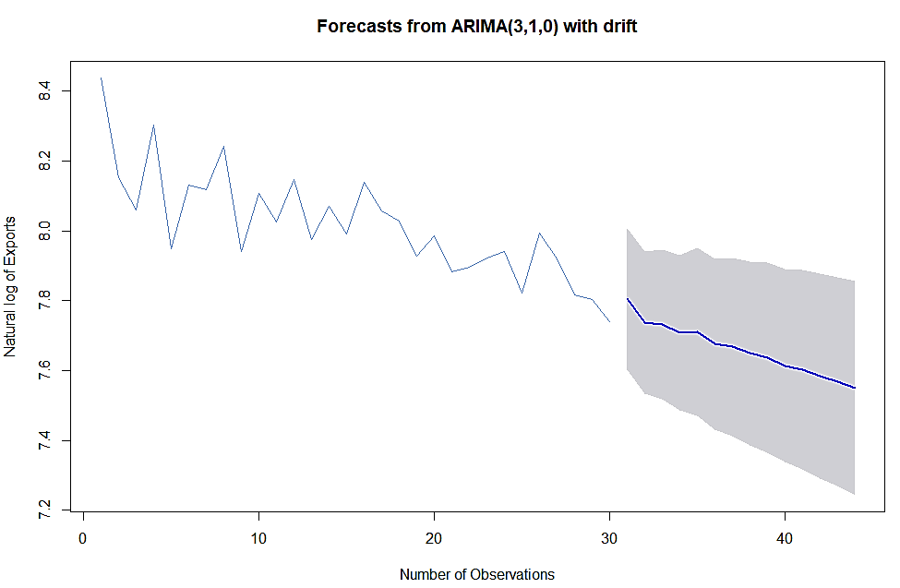
Figure 2. Mauritius-UK Exports (Rs Millions): ARIMA models.
Notes: Dark blue lines show the predictions for the period (2016Q3-2019Q4); Shaded regions depict the 95% confidence intervals of the predictions; y-axis: Natural logarithm of Exports (Rs Millions); x-axis: observation 30 refers to 2016Q2 when Brexit occurred.
Source: Authors’ creation.
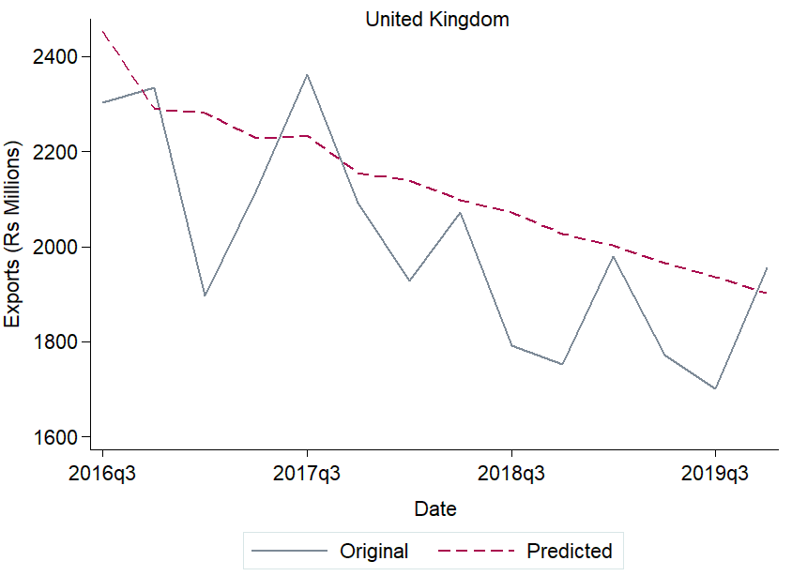
Figure 3. Forecasts for the period 2016Q3-2019Q4 (14 observations)
Source: Authors’ creation.
Concerning the other export markets (France and United States) that are considered as potential countries for controls, white noise is chosen for the Mauritius-France export market (ARIMA (0, 0, 0) with non-zero mean) and an ARIMA (3, 1, 2) with drift model (i.e. a three-order autoregressive and two-order moving average with an order of integration of one) for the Mauritius-United States export market. For both series, observed values are below those of the forecast values (see Figure 4). Nevertheless, the United States seems to be the most appropriate control because the observed values are somewhat closer to those predicted (see right panel of Figure 4). Additionally, from Table 1, it can be observed that as compared to France, Brexit has a much higher positive effect on the United States (+39.87%).
ARIMA (0,0,0) with non-zero mean | ARIMA (3, 1, 2) with drift
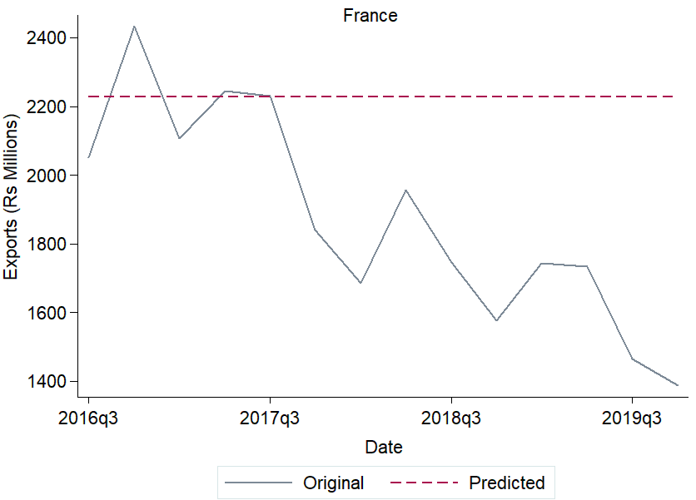 | 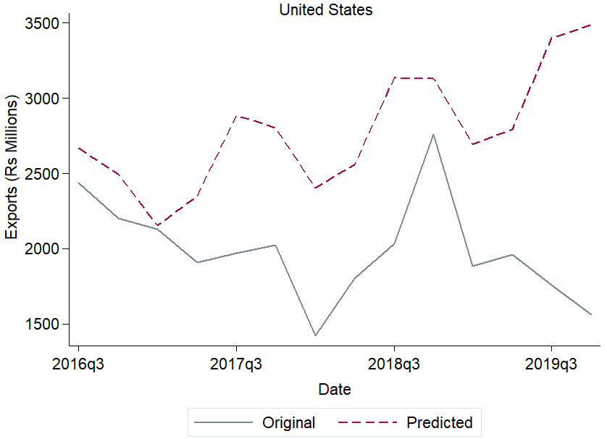
Figure 4. Forecasts for the period 2016Q3-2019Q4 (14 observations). ARIMA models.
Notes: Potential controls (France and United States export markets) for impact analysis; Solid line and dashed line represent the observed values and the forecasts for the period 2016Q3-2019Q4 respectively.
Source: Authors’ creation.

Table 1. Predicted and real exports 2016Q3-2019Q4. ARIMA models.
Country | Predicted Exports (Rs Millions) | Exports (Rs Millions) | Absolute effect | Relative effect
France | 2227.31 | 1871.21 | 356.10 | +19.03%
United States | 2782.72 | 1989.57 | 793.15 | +39.87%
Note: Average for the post-intervention period (2016Q3-2019Q4).
Source: Authors’ calculations.
Finally, we estimate the impact of the Brexit referendum on the Mauritius-UK export market using the methodology proposed by Brodersen et al. (2015). Figure 5 represents the results obtained when using the United States as the control series and Figures 6-7 depict those obtained when employing regression models. Considering the whole post-intervention period (2016Q3-2019Q4), it can be observed from Figure 5 that on average the purchases of UK has a value of 7.60 (in logarithmic terms) amounting to a total of Rs 1998.20 million. However, if the Brexit referendum did not occur, this figure would have been on average 7.96 (Rs 2864.07 million) with a prediction interval of [2724.39, 3010.92]. In other words, the Mauritius-UK export market incurred an absolute loss of Rs 865.88 million following the Brexit referendum. In relative terms, this accounts for a decrease of 5% with an interval of [-5%, -4%] in this particular market for the whole post-intervention period (2016Q3-2019Q4). This negative effect is significant at the 1% significance level [p-value = 0.0002].
On the other hand, whenever the respective export market is regressed against the bilateral exchange rate (Rs/GBP), both static and dynamic models show that this effect is not statistically significant. From the lower plot of Figure 6, it can be observed that despite the impact of Brexit referendum on the respective export market is negative, it is relatively small (approximately 1%). However, the findings from the dynamic regression model reveal that almost no change occurs in the respective market following the Brexit referendum (see the lower plot in Figure 7). We can, thus, deduce that the decrease in the Mauritius-UK export market is not driven by the global depreciation of the pound sterling.
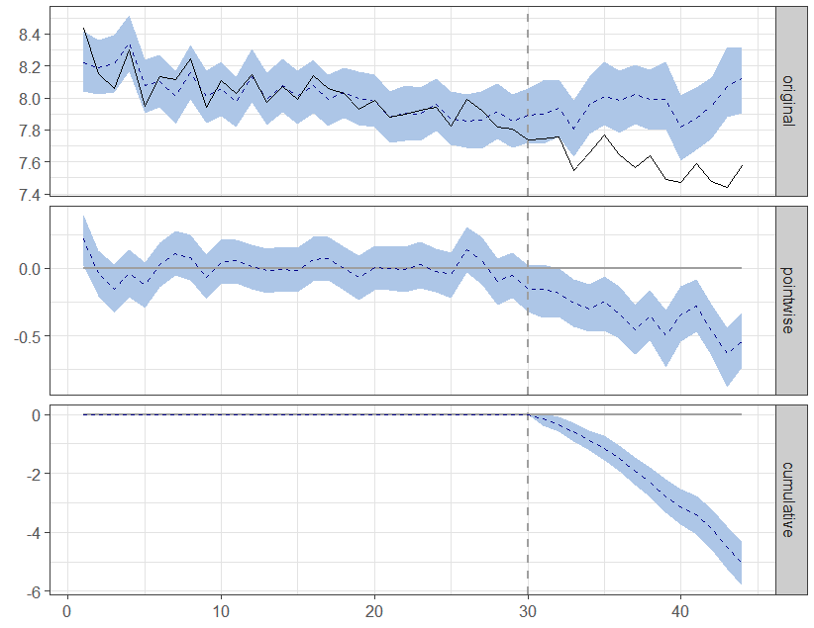
Figure 5. Impact of Brexit on the Mauritius-UK export market
Source: CausalImpact R-package output.
Notes: Mauritius-United States export market as control series; y-axis: Natural logarithm of Exports (Rs Millions); Dotted line representing the occurrence of the Brexit referendum (2016Q2 - Observation 30 on the x-axis); Top plot showing the observed series (black) and its predicted values (dotted blue) from the control series; Middle plot showing the difference between the prediction and the observed values; Bottom plot showing the total effect of these differences within the post-intervention period.

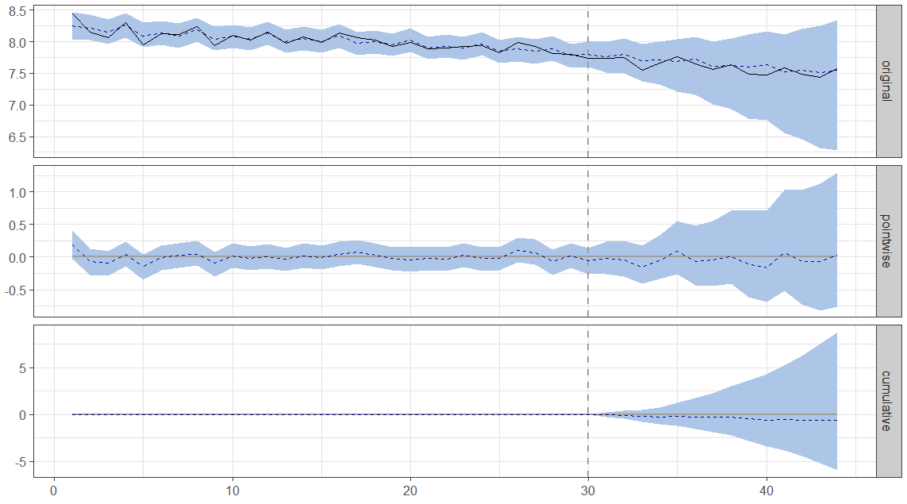
Figure 6. Impact of Brexit on the Mauritius-UK export market (static regression)
Notes: y-axis: Natural logarithm of Exports (Rs Millions); Dotted line representing the occurrence of the Brexit referendum (2016Q2 - Observation 30 on the x-axis); Top plot showing the observed series (black) and its predicted values (dotted blue); Middle plot showing the difference between the prediction and the observed values; Bottom plot showing the total effect of these differences within the post-intervention period.
Source: CausalImpact R-package output.
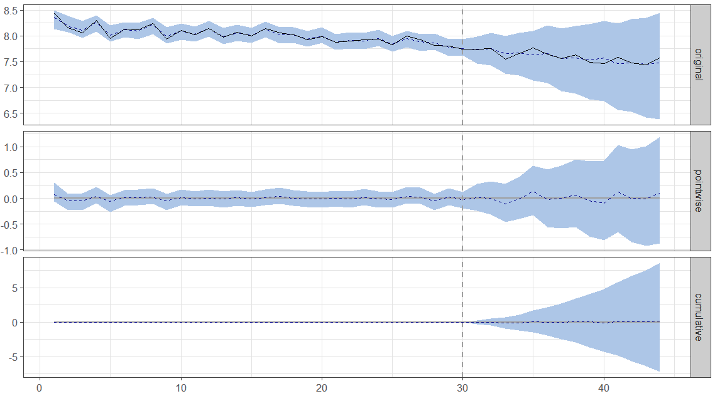
Figure 7. Impact of Brexit on the Mauritius-UK export market (dynamic regression)
Note: See Figure 6.
Source: CausalImpact R-package output.

- Conclusions
The United Kingdom remains one of the top export markets of Mauritius for the last few years. This study sets out to analyse the trend in this specific market during the post-Brexit referendum period (2016Q3-2019Q4). In particular, we examined the impact of the Brexit referendum on the Mauritius-UK export market using quarterly data (2009Q1-2019Q4) and the recently developed Bayesian structural time-series model for causal analysis. Preliminary analysis of the time-series data confirmed that this export market encountered a fall following the Brexit referendum: observed values were lower than those predicted by the selected optimal ARIMA model. Additionally, relying upon the results of the time-series analysis within the ARIMA model framework, the Mauritius-United States export market was used as a potential control series for further analysis. The findings from the causal analysis revealed that the Brexit referendum has a negative and significant effect on the Mauritius-UK export market. In particular, this respective market incurred an absolute loss of Rs 865.88 million following the Brexit referendum. However, the results obtained from both the static and dynamic regression models showed that this negative effect was not due to the depreciation of the pound sterling worldwide.
Despite that this effect only accounted to about 5% decrease in the respective export market, the findings from this study suggest reinforcing and consolidating the existing trade policies and also closely monitor the new bilateral trade agreement with the UK (the Economic Partnership Agreement signed on 31st January 2019 with the UK that will guarantee continued preferential access for Mauritian products to British soil after Brexit) to mitigate any future potential loss following the transition period with the Brexit. However, a lot will depend not only on the content of the eventual Agreement which UK will conclude with the EU but also on future agreements which UK will conclude with our direct competitors such as China, India, South Africa and other Asian Countries. Mauritius risk to witness an erosion of its market access if the UK opens up its market to these countries for garments, canned tuna, sugar, jewellery and other products which are exported to the UK and Mauritius should further deepen and accelerate its export market diversification. Finally, the bilateral exchange rate should also be closely monitored by the Bank of Mauritius together with the appropriate monetary and exchange rate policies.

References
Allen, K., Treanor, J., & Goodley, S. (2016, June 23). Pound slumps to 31-year low following Brexit vote. The Guardian. https://www.theguardian.com/business/2016/jun/23/british-poundgiven-boost-by-projected-remain-win-in-eu-referendum

Brodersen, K.H., Gallusser, F., Koehler, J., Remy, N. and Scott, S.L., 2015. Inferring causal impact using Bayesian structural time-series models. The Annals of Applied Statistics, 9(1), 247-274.
Brodersen, K., 2016. How long should the period be? Available from: https://stats.stackexchange.com/questions/128775/is-it-okay-to-run-causalimpact-in-r-on-successive-portions-of-a-time-series [Accessed 15 October 2019].
Gelman, A., Carlin, J. B., Stern, H. S., Dunson, D. B., Vehtari, A., & Rubin, D. B. (2013). Bayesian data analysis: Third edition. Boca Raton, FL: CRC Press.

Hyndman, R.J. and Khandakar, Y., 2008. Automatic time series forecasting: The forecast package for R. Journal of Statistical Software, 26(3), 1-22.
Perles-Ribes, J.F., Ramón-Rodríguez, A.B., Such-Devesa, M.J. and Moreno-Izquierdo, L., 2019a. Effects of political instability in consolidated destinations: The case of Catalonia (Spain). Tourism Management, 70, 134-139.
Perles-Ribes, J.F., Ramón-Rodríguez, A.B. and Ortuño Padilla, A., 2019b. Brexit announcement: Immediate impact on British tourism in Spain. Cornell Hospitality Quarterly, 60(2), 97-103.
Perles-Ribes, J.F., Ramón-Rodríguez, A.B., Moreno-Izquierdo, L. and Torregrosa Martí, M.T., 2018. Winners and losers in the Arab uprisings: a Mediterranean tourism perspective. Current issues in Tourism, 21(16), 1810-1829.
Statistics Mauritius 2020. Retrieved from: http://statsmauritius.govmu.org/English/Publications/Pages/all_esi.aspx [Accessed 20 February 2020]

In terms of Continent, the shares are as follows: Europe (45%), Africa (26%), Asia (16%) and America (11.4%) respectively.
See Brodersen et al. (2015) and Perles-Ribes et al. (2018) for an in-depth explanation on this methodology.
This methodology was proposed by Brodersen et al. (2015). For causal inference within the Bayesian time-series model framework, the CausalImpact R package is used (Brodersen et al., 2015).
This is done using the automated procedures of the forecast package of R (Hyndman and Khandakar, 2008).
The Bayesian structural time-series model framework for causal analysis.
For both the static and dynamic regressions, the respective export market is regressed against the bilateral exchange rate.
Static: p-value = 0.281; Dynamic: p-value = 0.500.

