Shanghai Open Economy Forum | Shanghai University of International Business and Economics jointly organized the "2020 Global Trade and Economic Governance Forum" with the World Trade Organization, the Chinese Academy of International Trade and Economic Cooperation and the China Society for World Trade Organization Studies

On October 18th, "2020 Global Trade and Economic Governance Forum" was grandly held on Gubei Campus of Shanghai University of International Business and Economics (SUIBE). The forum was co-organized by the World Trade Organization (WTO), the Chinese Academy of International Trade and Economic Cooperation (CAITEC) of MOFCOM, the China Society for World Trade Organization Studies (CWTO), and co-hosted by the School of Trade Negotiations of SUIBE, the WTO Chair Institute-China of SUIBE, the WTO Partner Institution for Regional Trade Policy Course in the Asia and Pacific Region of SUIBE, World Trade Organization Research Center of SUIBE, and Shanghai Center for Global Trade and Economic Governance (SC-GTEG) of SUIBE. This forum is one of the series events of "Shanghai Open Economy Forum", and it is also an important high-level academic conference for the 60th Anniversary of SUIBE, which is supported by the WTO Chairs Programme.
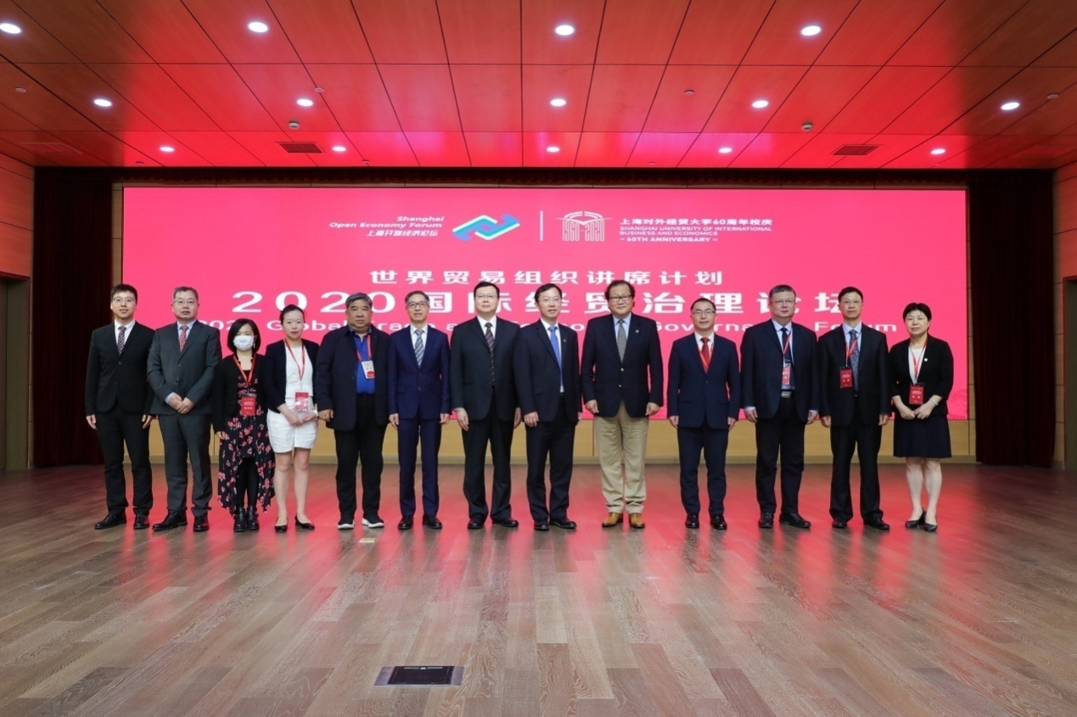

Mr. Zhou Hanmin, Vice Chairman of Shanghai CPPCC; Prof. Wang Rongming, President of SUIBE; Mr. Jin Xu, President of China Association of International Trade(CAIT); Mr. Yu Guangsheng, Vice Chairperson of the Executive Committee of CAITEC; Mr. Zhang Guohua, Vice Director of Shanghai Municipal Commission of Commerce; Mr. Robert Koopman, Director andChief Economist, Economic Research and Statistics Division of WTO; Ms. Mia Mikic, Director of Trade, Investment and Innovation Division of UN Economic and Social Commission for Asia and the Pacific (ESCAP); Mr. Li Gang, Vice President of CAIT, Prof. Lin Guijun, Dean of National Opening Research Institute of UIBE; Ms. Huang Yu, Director of Shanghai Municipal Commerce Development Research Center and other leaders and guests attended the forum. More than 160 guests from universities, research institutes and enterprises all over the country and experts, scholars and students from SUIBE attended the forum. Prof. Xu Mei, Vice Chairperson of the Executive Committee of SUIBE, presided over the opening ceremony of the forum.
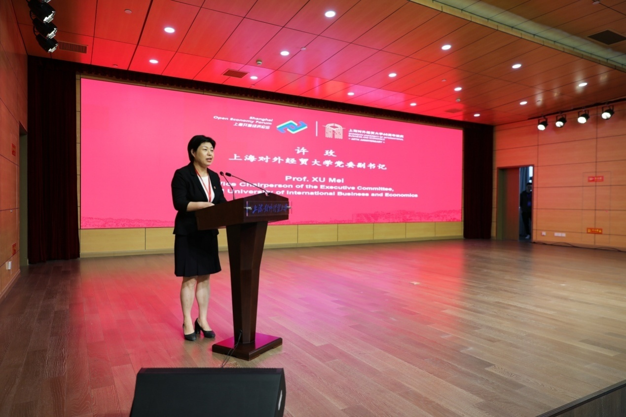

Prof. Wang Rongming, President of SUIBE, gave a welcome speech at the opening ceremony. He pointed out that since its establishment, Shanghai University of International Business and Economics has always adhered to the cultivation of high-level and international applied talents in international economic and trade, and has always adhered to the direction of scientific research serving the country and Shanghai's economic and social development, providing important talent support and intellectual support for the development of China's economic and trade undertakings and the implementation of national opening-up initiatives such as "Re-entry into GATT" and "Entry into WTO", "Shanghai Pilot Free Trade Zone" and "the Belt and Road Initiative", thus being selected as one of the first batch of WTO Chair institutions as well as the only one in China. In 2013, the University set up an Shanghai Center for Global Trade and Economic Governance, and was selected as one of the first batch of University Think Tanks in Shanghai. In 2017, the University established the School of Trade Negotiations and the WTO Chair Institute-China. Deputy Director-General of the WTO, H.E. Yi Xiaozhun attended the unveiling ceremony. The School of Trade Negotiations is the first academic institution specializing in training high-level talents in trade negotiations in China. In 2019, the WTO carried out a third-party evaluation for 19 chair institutions around the world. According to the evaluation, the School of Trade Negotiation and the WTO Chair Institute-China of SUIBE have become among the most relevant academic research and training institutions in WTO issues in China, and "a true Chinese 'centre of excellence' on WTO issues". On this basis, the University is selected by the WTO as a new partner institution of the Regional Trade Policy Course for the Asia and Pacific members and observers of the WTO. This is the only regional training partner in mainland China selected by the WTO, and it is also the first time that the university in mainland China has won this programme. This will help deepen the economic and trade exchanges and cooperation between China and countries along the "the Belt and Road Initiative" in the Asia-Pacific region, provide talent support for China's participation in international economic and trade governance, and help China build a new pattern of comprehensive opening up. Prof. Wang Rongming said that in the long-term development and scientific research activities, the University has always paid close attention to the most important issues in the international economic and trade field, and will continue to uphold the fine tradition of serving the country by academic achievements, while paying attention to the major issues and frontier trends in the international economic and trade field. He hoped that this forum would build a good platform for in-depth exchanges and discussions, and contribute to professional solutions for improving the international economic and trade governance system.
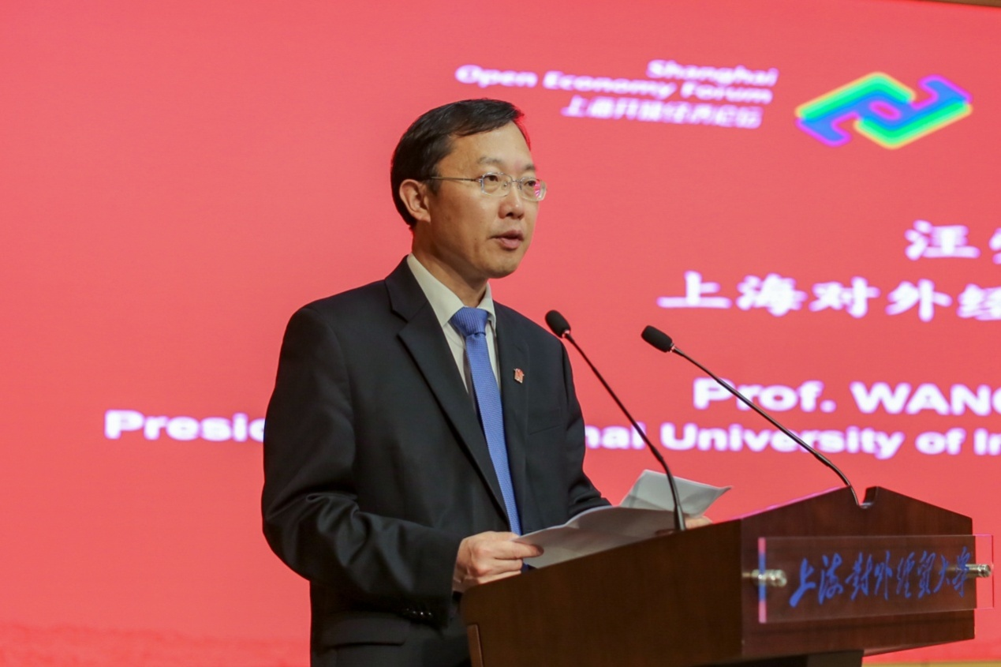
H.E. Yi Xiaozhun, Deputy Director-General of the World Trade Organization, and Mr. Chong Quan, Chairman of China Society for World Trade Organization Studies, delivered speeches at the opening ceremony by video and online respectively.

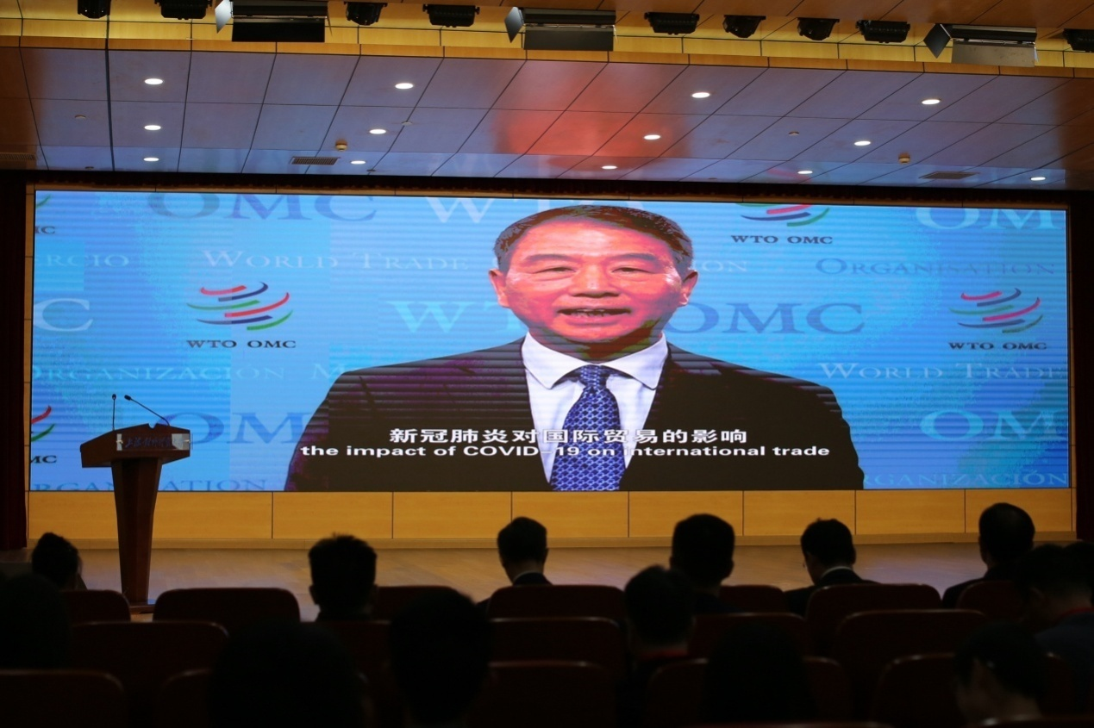

Subsequently, Prof. Zhou Hanmin, Mr. Yu Guangsheng, Mr. Zhang Guohua and Mr. Jin Xu delivered keynote speeches separately on the topics of " Urgent Needs of Legal Coordination in International Economic and Trade System Reform", "New Challenges in Global Economic and Trade Governance", "High-level Openness Leads the New Direction of International Economic and Trade Governance" and "Exclusivity of Evolution of International Economic and Trade Rules".
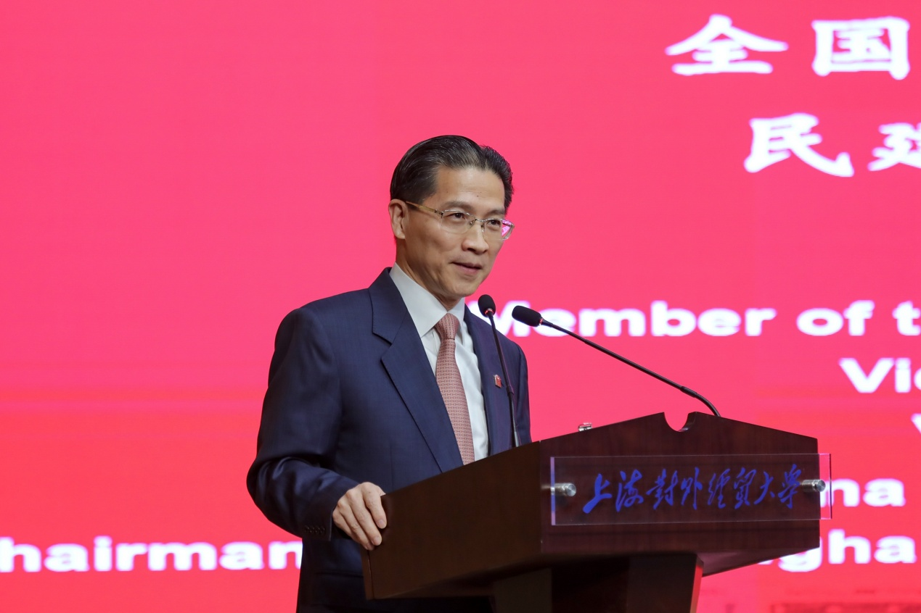
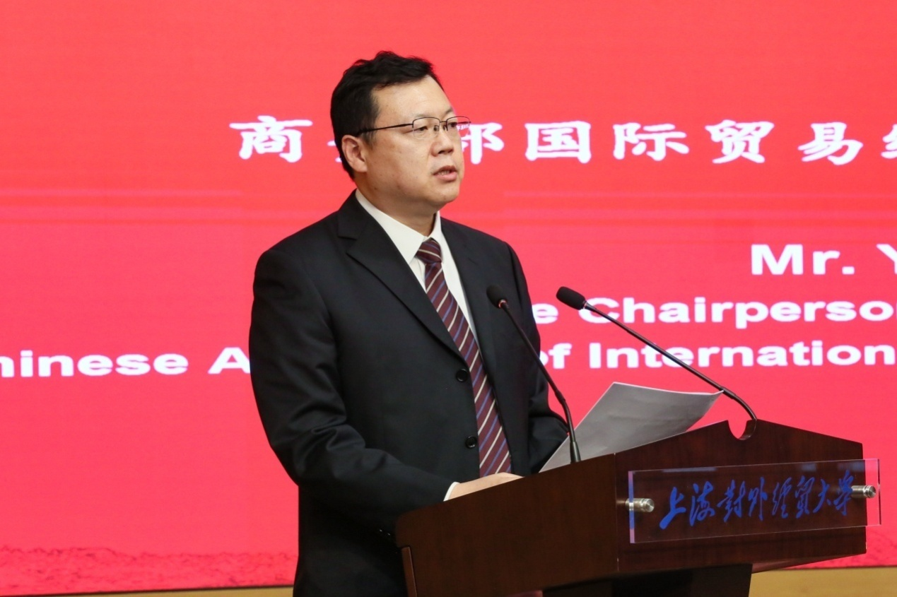
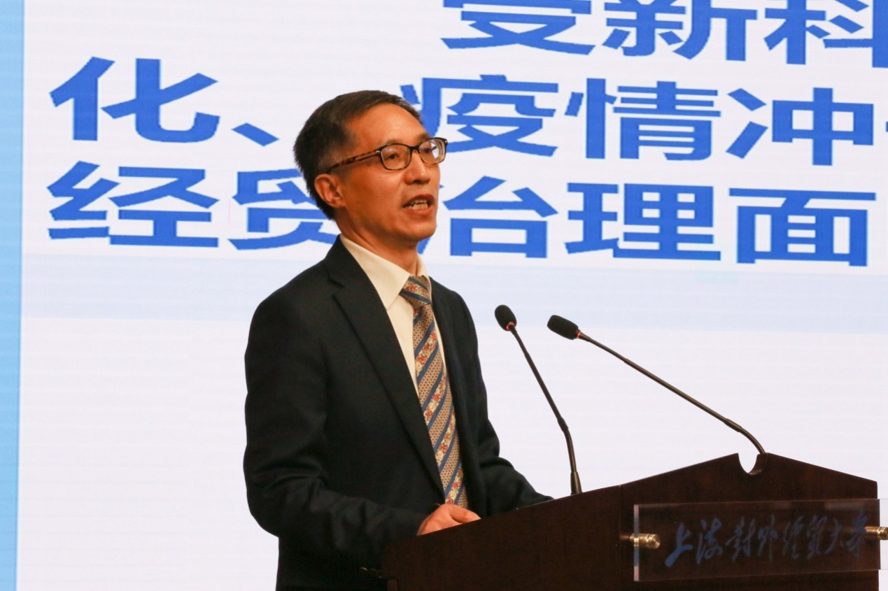
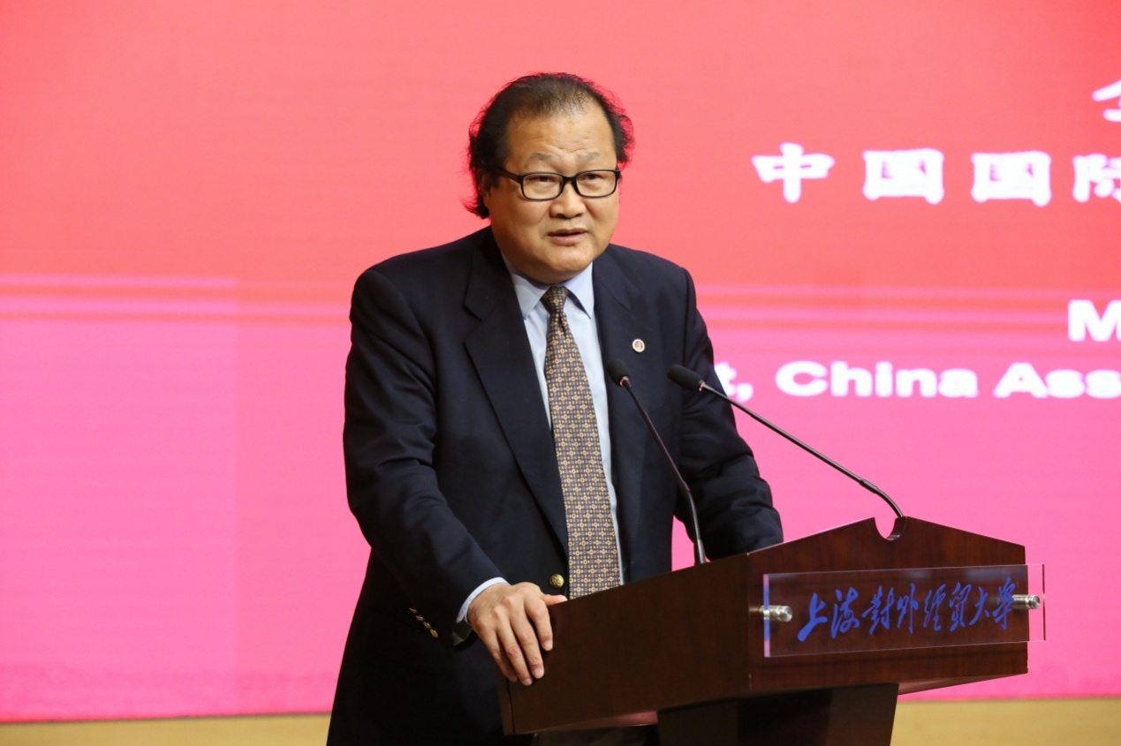

The forum focused on the theme of “COVID-19 and International Trade - Potential Implications for Globalization and Long Term Economic Growth”, and the discussion session was chaired by Prof. Zhang Lei. Mr. Robert Koopman, Ms. Mia Mikic, Mr. Li Gang, Prof. Lin Guijun, Ms. Huang Yu and other guests delivered speeches on the topics of "COVID-19 Epidemic and International Trade: The Trend of Global Value Chain", "Improving Risk Prevention and Control, Reducing the Cost of Global Value Chain", etc. After the in-depth academic discussions, plentiful and substantial theoretical ideas and policy suggestions were raised. The forum was brilliant and achieved fruitful research results.
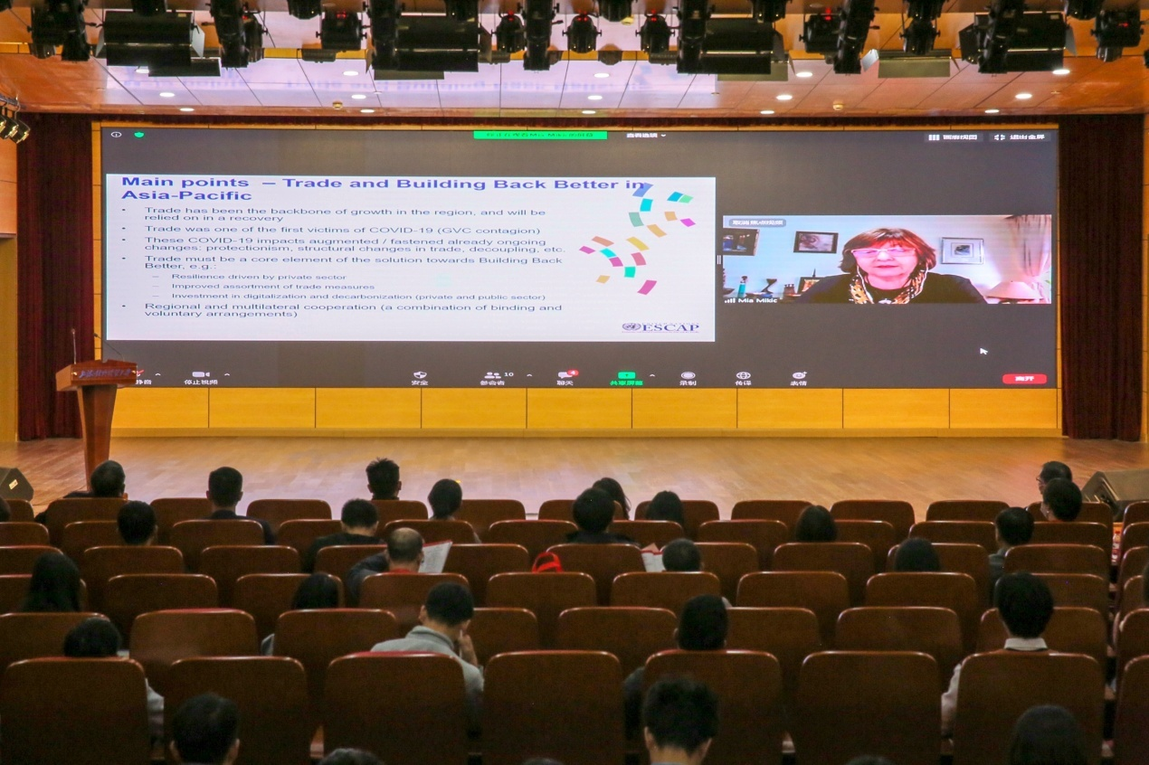
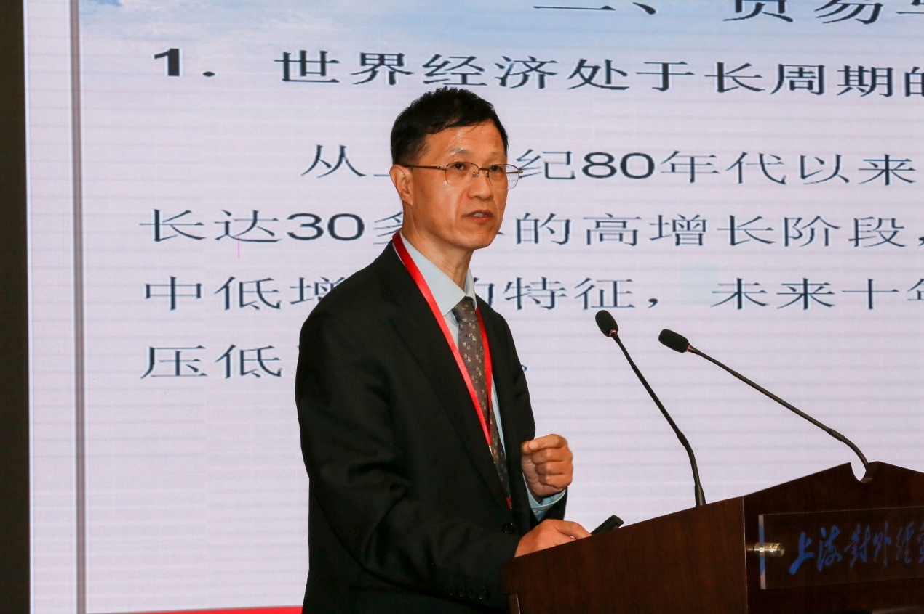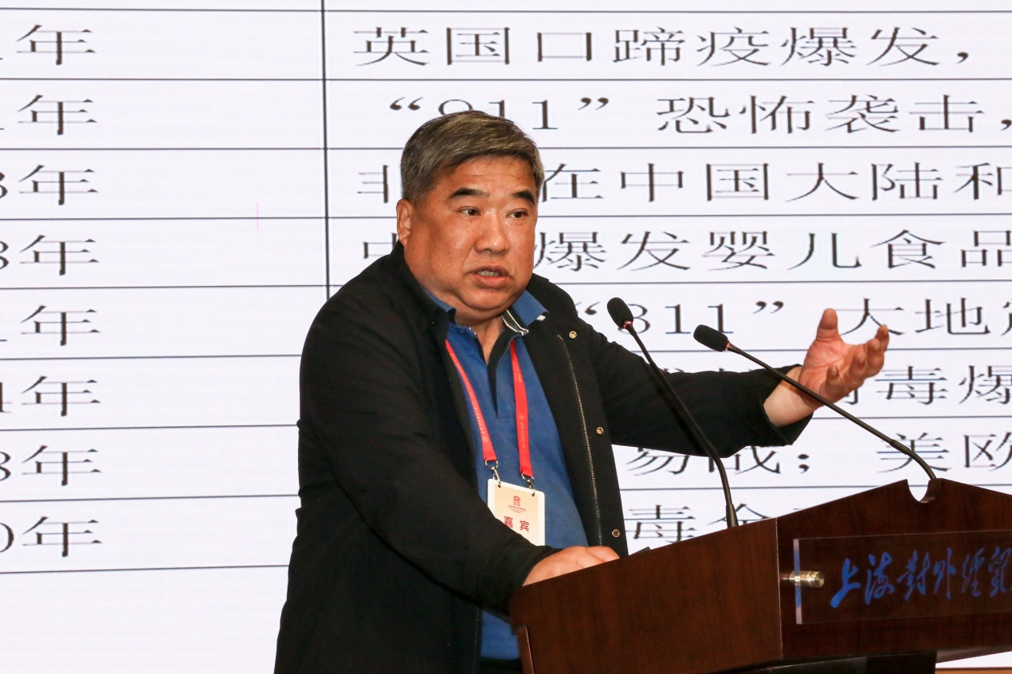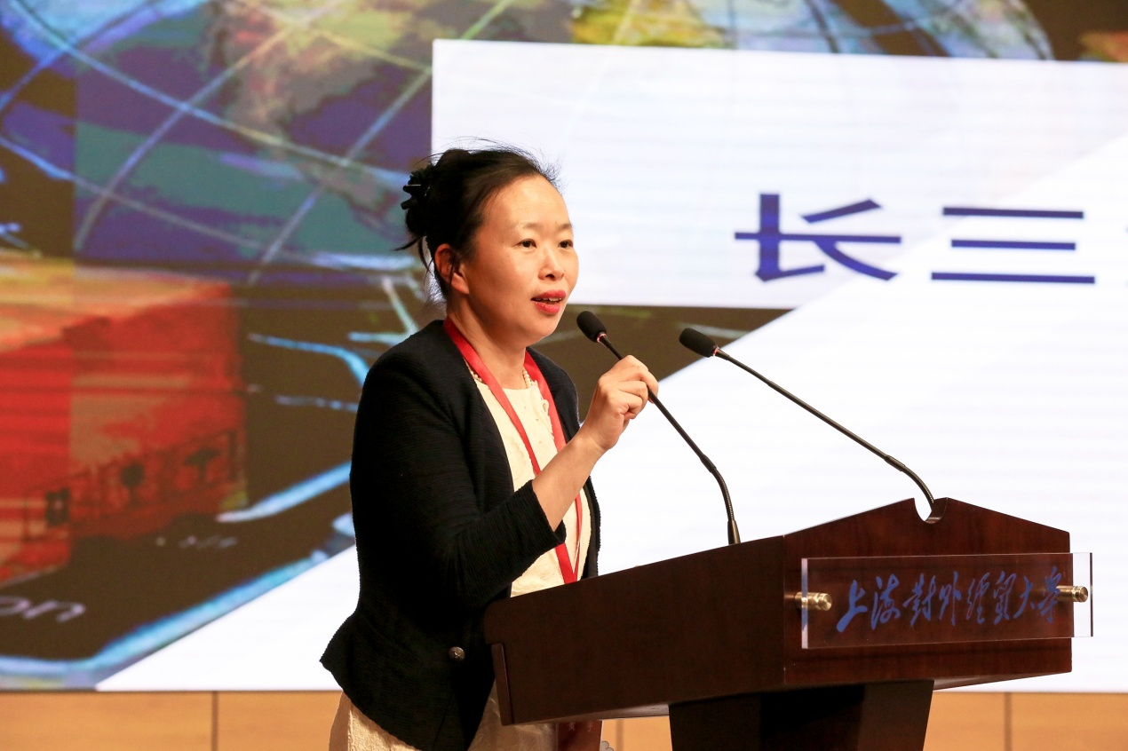
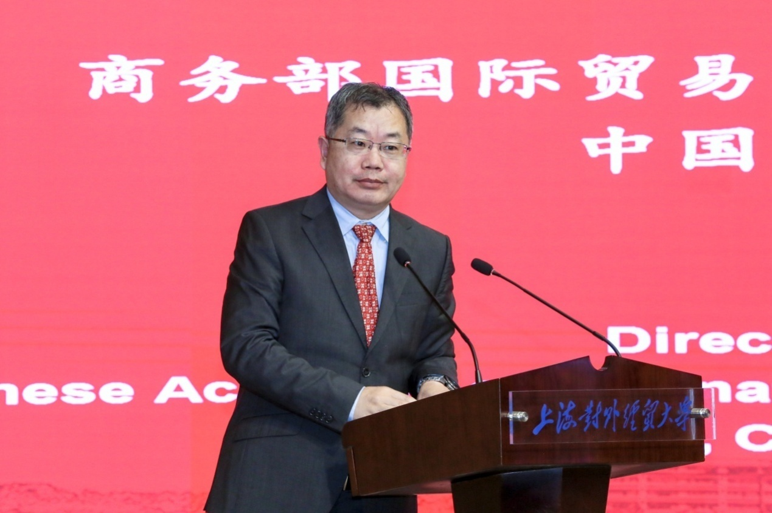

Finally, Mr. Robert Koopman made a concluding speech for the forum, and Prof. Ying Pinguang delivered a closing speech. The forum ended successfully.
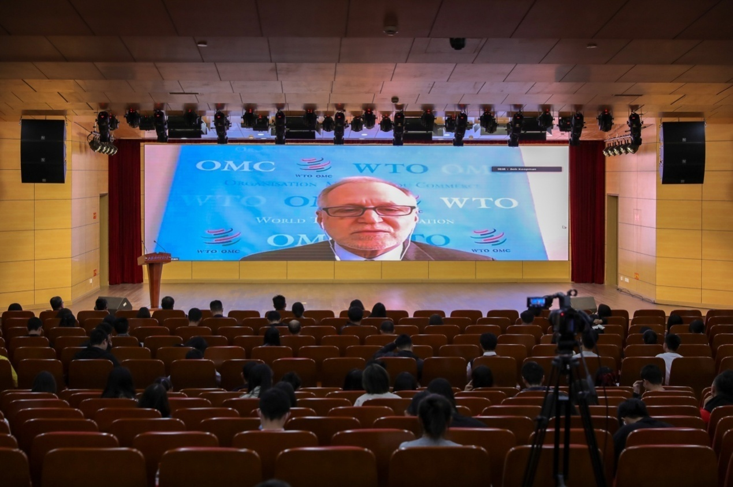
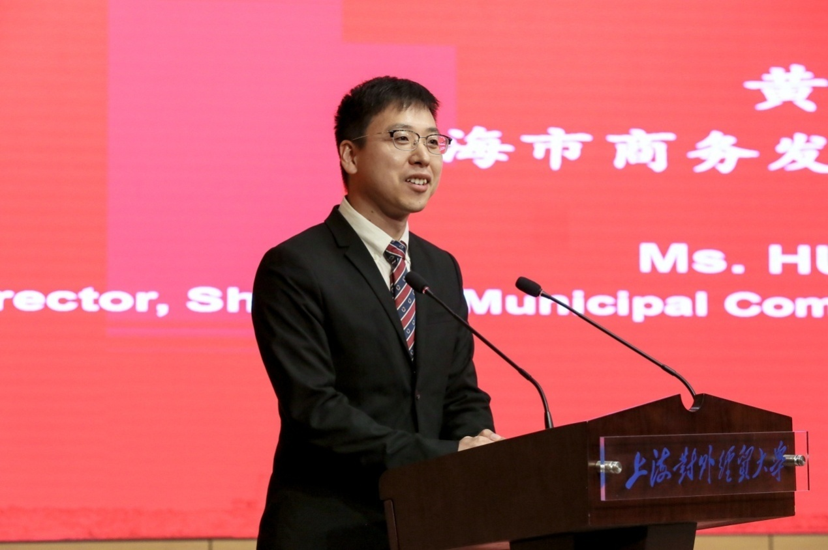

While expanding the academic and social influence of Shanghai University of International Business and Economics in the field of international economic and trade governance, this forum also presented a congratulatory gift to the University’s 60th anniversary celebration.
