SUIBE Held “Book Launch World Trade Report 2020: Government Policies to Promote Innovation in the Digital Age”
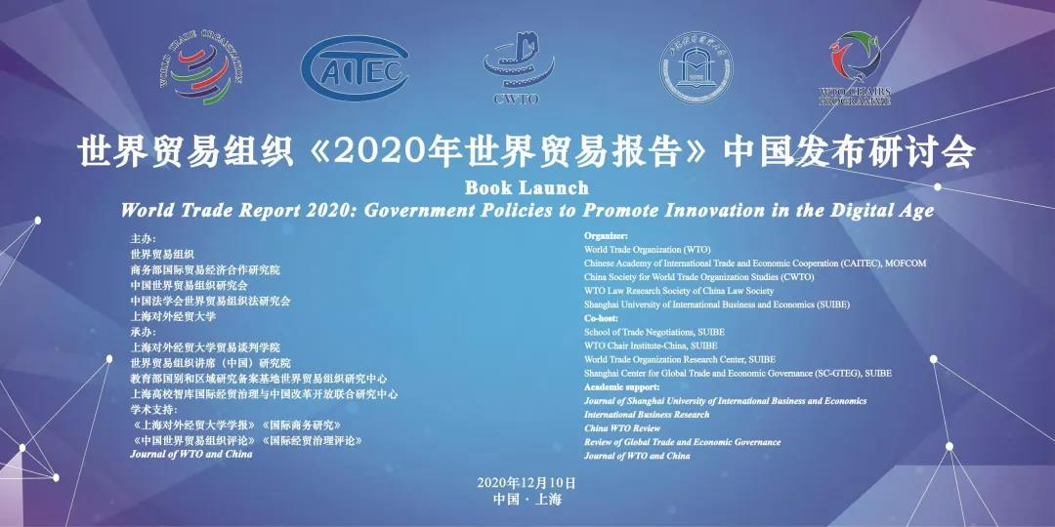
On December 10th, “Book Launch World Trade Report 2020: Government Policies to Promote Innovation in the Digital Age” was grandly held online. This seminar was organized by the World Trade Organization(WTO), Chinese Academy of International Trade and Economic Cooperation (CAITEC), MOFCOM, China Society for World Trade Organization Studies (CWTO), WTO Law Research Society of China Law Society and Shanghai University of International Business and Economics（SUIBE）, and co-hosted by the School of Trade Negotiation of SUIBE, WTO Chair Institute-China, SUIBE, World Trade Organization Research Center, SUIBE, and Shanghai Center for Global Trade and Economic Governance (SC-GTEG), SUIBE. This seminar was supported by the WTO Chairs Program (WCP).
Mr. Qian Keming, Vice Minister of Commerce, Mr. YI Xiaozhun，Deputy Director-General of WTO, Mr. CHONG Quan，Chairman, China Society for World Trade Organization Studies, Mr. Robert Koopman, Chief Economist and Director of Economic Research and Statistics Division of WTO, Mr. Marc Auboin, Counsellor of Economic Research and Statistics Department of WTO, Ms. Xu Ankai, Economist of Economic Research and Statistics Department of WTO, Enkai Jianguo, Vice Chairman of CWTO, Mr. Qu Weixi, Vice President of CAITEC, Mr. Xu Qingjun, Counsellor of the Permanent Mission of the People's Republic of China to the WTO and other leaders and guests attended this online seminar.
The World Trade Report 2020, released by the WTO, focuses on "Government Policies to Promote Innovation in the Digital Age". The report focuses on the latest trend of global trade and points out that the world economy is shifting toward digitalization and informationization. Focusing on the topic of " Government Policies to Promote Innovation in the Digital Age ", the report analyzes the policies and trends of governments supporting the transition to digital economy, promoting digital innovation, economic innovation and technological progress in recent years, as well as the impact of this trend on trade flows and global business, and provides useful insights for the possible global trade pattern in the future.
The welcome speech was delivered by Professor Xu Mei, Vice Chairperson of the Executive Committee, SUIBE at the Opening Ceremony. Mr. Qian Keming, Vice Minister of Commerce, Mr. YI Xiaozhun，Deputy Director-General of WTO, Mr. CHONG Quan，Chairman, China Society for World Trade Organization Studies, delivered opening speeches respectively. This seminar was chaired by Zhang Lei , the WTO Chair Holders of the WTO, and Dean of the School of Trade Negotiations, and WTO Chair Institute-China of SUIBE.
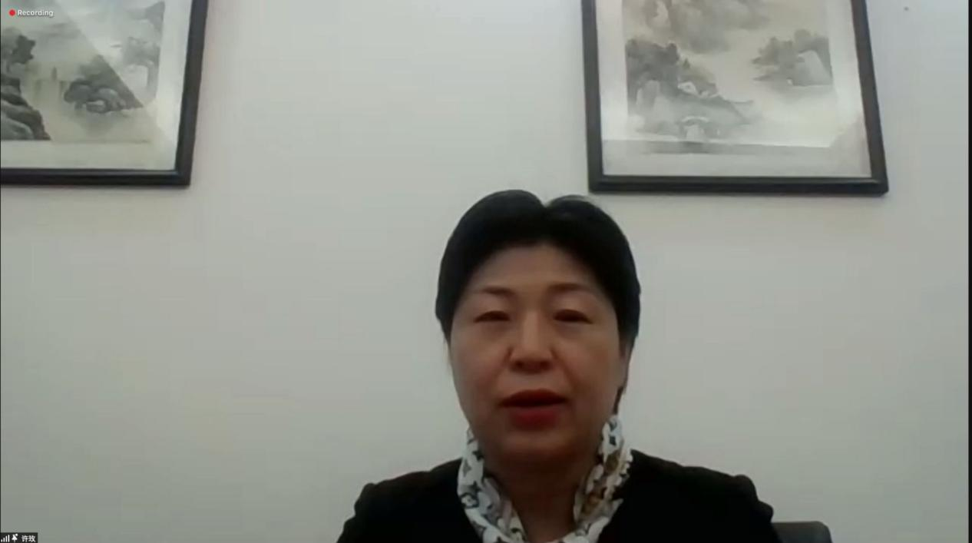
Professor Xu Mei pointed out that SUIBE has a long history with WTO, before China's entry into WTO, SUIBE made due contributions to China's integration into the world market and opening the door of China's prosperous times through a large number of consultation studies on the decision-making of "re-entry to customs" and "entry into WTO". After China's entry into WTO, SUIBE has carried out a series of theoretical and practical explorations around multilateral and bilateral economic and trade cooperation with the research of multilateral trade system as the core. With the support of the Ministry of Commerce, in May, 2008, SUIBE set up " China-WTO Dispute Settlement Mechanism Center ", the first academic institution specializing in WTO dispute settlement mechanism. In 2009, SUIBE was selected as the WTO Chair Institute, which is the only one in China. In November 2012, SUIBE established the "WTO Trade Policy Review Center", the earliest specialized academic institution in China to study the WTO trade policy review mechanism; SUIBE has always resonated with the country's opening to the outside world at the same frequency, which has formed distinct school-running characteristics and has become an important base for training foreign trade talents in China.
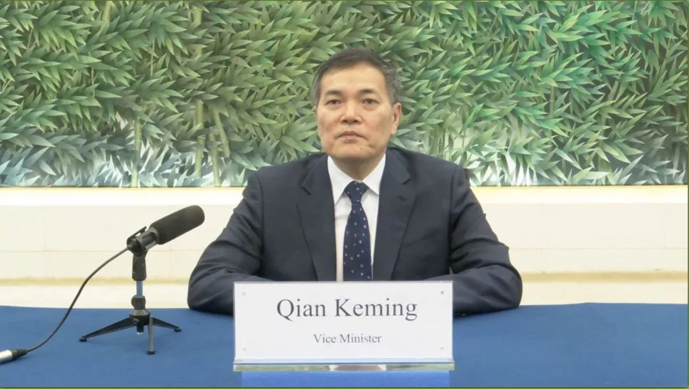
On behalf of the Ministry of Commerce of China, Vice Minister Qian Keming first congratulated the English version of the World Trade Report 2020 of WTO on its release during the special period of COVID-19 pandemic, and wished the seminar in China achieved fruitful results.
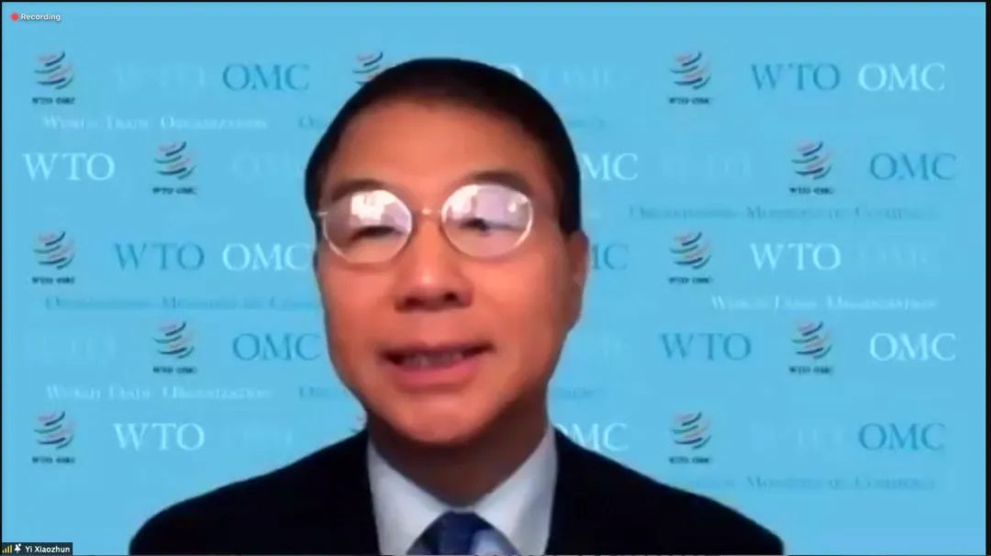
Deputy Director General Yi Xiaozhun pointed out that in the digital age, a growing number of countries have adopted policies aimed at boosting growth through innovation and technological upgrading. This year's World Trade Report looks at these trends, and how the WTO integrate into that.
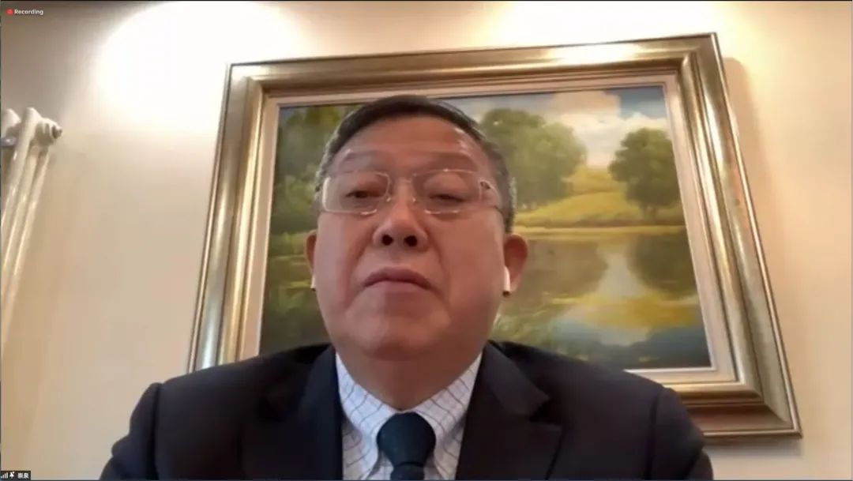
President Chong Quan pointed out that human is entering a new era—the digital age. Digital economy is the future development trend of the world, and the epidemic further highlights the importance of digital economy, so the world trade reports in recent years all involve digital economy.
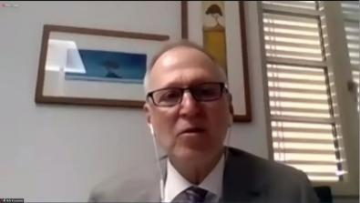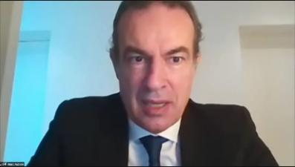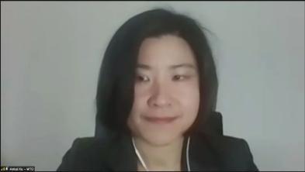
Mr. Robert Koopman, Chief Economist and Director of Economic Research and Statistics Division of WTO, Mr. Marc Auboin, Counsellor of Economic Research and Statistics Division of WTO, and Mahankali Xu, Economist of Economic Research and Statistics Division of WTO, respectively interpreted the World Trade Report 2020.

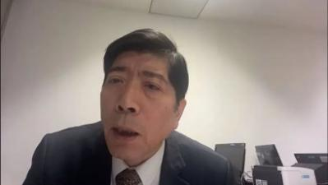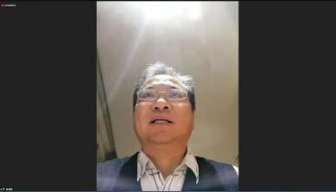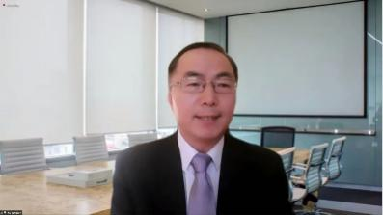
Huo Jianguo, Vice President of CWTO, Qu Weixi, Vice President of CAITEC, MOFCOM, and Xu Qingjun, Counsellor of the Permanent Mission of the PRC to the WTO, and other experts and scholars launched online comments and reviews on important topics in the World Trade Report 2020.
Finally, Professor Zhang Lei made a closing remarks. He pointed out that this year's World Trade Report focuses on " Government Policies to Promote Innovation in the Digital Age ", which is an important topic for the future. It summarizes the achievements of the WTO in the past 25 years, and at the same time, it captures the pulse of the times, which provides enlightenment for future negotiations of WTO rules in the digital economy era.
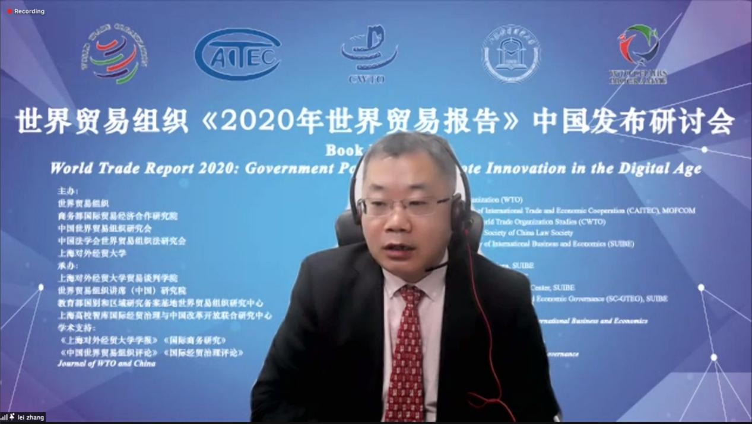
This “Book Launch World Trade Report 2020: Government Policies to Promote Innovation in the Digital Age" came to a successful conclusion. The conference expanded the academic and social influence of SUIBE in the field of global trade and economic governance.

