|  |
| --- |
| No Chinese Jackets Required: Clothing Quotas, Consumer Prices and Import Quality in South Africa* |
|  |
|  |
| Lawrence Edwards  School of Economics  University of Cape Town  Tasha Naughtin and Neil Rankin  African Micro-Economic Research Unit (AMERU)  University of the Witwatersrand |
| September 2011 |

|  |
| --- |
|  |

In January 2007 South Africa placed quantitative restrictions (quotas) on a number of Chinese clothing and textile product lines. Trade theory predicts that the imposition of binding quotas on a set of goods will result in a price increase for these goods. In a perfectly competitive market, these price increases will be passed onto domestic consumers. This paper uses a unique dataset of consumer prices to investigate whether this happened in South Africa. Using a difference-in-differences methodology we find no evidence that the prices that South African consumers paid for products in the restricted lines changed relative to non-restricted product lines. One explanation for this, for which we find evidence, was that South African importers substituted towards other low cost producers (including those in the SADC region) thus leaving prices unchanged. Furthermore, we find that there was quality upgrading, as measured by higher per-unit prices, in imports of Chinese products in the restricted lines, and quality downgrading in imports from other SADC countries and other competing countries. There is also evidence that trade values from SADC countries increased after the quota was scrapped indicating that the quota may have allowed these countries to gain a foothold in the South African market. The analysis of this natural experiment demonstrates that quotas are ineffectual in restricting import competition if other close substitutes, produced in non-quota constrained countries, exist.

**1. Introduction**

Between 1996 and mid-2006 the South African clothing and textile sector lost almost 87,000 jobs – a decrease in employment of 37 percent (Vlok, 2006). Over the same period China’s market share in the sector rose from 20 to 75 percent (Sandrey, 2006). As a response to lobbying from domestic producers and labour organizations, and in an attempt to limit import competition, the South African government entered into a bilateral trade agreement with the People’s Republic of China to restrict imports of 31 categories of clothing and textiles. On 1 January 2007 these quantitative restrictions (quotas) were implemented for a two year period.

Notwithstanding the potential benefits of this agreement to South African producers, support from other constituencies was weak. Retailers maintained that government should ‘scrap the quotas’ cautioning that they will ‘create chaos and hurt consumers’ (Musgrave & le Roux, 2006). Indeed some retailers expected an inflationary effect of 20-25 percent on prices of some categories of clothing while other retailers indicated that they would find other countries to import from. These concerns were not unwarrented. Trade theory suggests that a binding quota will raise prices and cause quality upgrading (Harrigan & Barrows, 2006). Further, van Eeden and Sandry (2007) suggest that ‘the quotas may even have done more damage than good as importers have established a variety of new markets to source from in future.’

Most of the existing research on the impact of these South African quotas has been descriptive, and mostly undertaken by researchers at the Trade Law Centre for Southern Africa (tralac). Some of this work has shown that SA’s total clothing and textiles imports did not decrease as a result of retailers sourcing imports from other low cost Asian producers such as Mauritius, Malaysia and Bangladesh (Van Eeden & Fundira, 2008). However, estimates by Naude and Rossouw (2008) of the potential impact of the quotas derived using a computable general equilibrium (CGE) model of the South African economy predicted prices increased of up to 20 percent for the imported products and an overall cost to the economy of R1 billion.

Quotas also have an impact beyond price. Theoretical models of trade such as Falvey (1979) predict that they lead to quality upgrading. This occurs since the quota acts as an additional fixed per-unit cost which makes higher quality, and priced, quota-constrained goods relatively cheaper compared to lower priced quota-constrained goods. This leads to substitution into higher quality products within the quota constrained import categories. International studies such as Aw and Roberts (1986), Feenstra (1988), Boorstein and Feenstra (1991) and Anderson (1991) find evidence for this.

Despite these potential impacts, quotas are an attractive policy option for countries faced with increases in imports that crowd out local producers. This is particularly the case in the clothing and textile sector which experiences intense competition from goods manufactured in China. It is thus useful to know what the impact of quotas are, particularly for countries, such as those in the rest of the Southern African Development Community (SADC), with developing clothing and textiles sectors.

This paper investigates the impact of the quotas on Chinese clothing and textile imports into South Africa. Binding quotas should increase the landed prices of goods in the constrained product lines which would be passed onto consumers if markets are perfectly competitive. We use a unique dataset – prices that consumers actually pay at the store level – to assess this. This is, to our knowledge, the first time this type of data has been used to investigate the impact of trade restrictions on consumers. Using this data we find no evidence that the prices that South African consumer paid for products in the restricted lines changed relative to non-restricted product lines.

There are a number of potential explanations of why this could be the case. The one that we find most support for is that the gap in relatively low-cost clothing and textile imports created by the quota was filled by similar imports from other low-cost countries such as other SADC countries, Vietnam and Indonesia. In line with evidence from other international studies, we also find that the per-unit prices of imports from China in the restricted product lines increased. This provides evidence of product quality upgrading.

The contribution of this paper is thus threefold. First, it demonstrates how micro-price data, collected at the product and store level, can be used to investigate the impact of trade restrictions on consumer prices. Second, it extends the analysis of the impact of the imposed quotas on Chinese goods on prices, volumes and values of clothing and textile imports into South Africa, and thus provides an indication of how the imposition of quotas may impact in similar developing countries. Third, it adds to the international evidence which indicates that quantitative restrictions result in quality upgrading among the quota-restricted goods.

The paper proceeds as follows. In the next section the theoretical background of the trade theory around quotas is discussed. This includes a brief discussion on the effects of the quota on quantities, prices and quality. Section 3 provides a discussion on the empirical literature surrounding the implications of imposing trade restrictions. Section 4 provides a broad overview of the South African clothing and textiles market and the data used. It also describes the econometric methodology used to analyse this data at a statistical level. Section 5 includes a descriptive and analytical study on the effects of the quota on these products first at the consumer level and then at the trade level. Finally section 6 concludes.

**2. Theoretical Background**

Protection of domestic producers is one of the key reasons for the use of trade barriers. These barriers may be in the form of tariffs or nontariff barriers such as import quotas or export restraints. An import quota is simply a direct limitation upon the physical quantity of a good that may be imported into a country over a period of time. This is usually enforced by issuing licenses to individuals or groups. This direct restriction has an indirect effect on the prices that can be charged on the domestic market for imported goods. When imports are limited the immediate result is that at the initial price the demand for the good exceeds the domestic supply plus imports. Consequently, the price is increased until the market clears.

By affecting the domestic price level, the quota affects consumer and producer surpluses, which in turn affects the overall welfare of the domestic economy. Protection through quantitative restrictions provides benefits to a small group of producers at the expense of a large number of consumers, and as a result overall national welfare falls.

Another less obvious effect of a quantitative restriction involves the composition of imports. According to Santoni and Van Cott (1980) the response to a quota has generally only been described in terms of ‘the characteristic which is formally limited by the quota – usually the physical units of the commodity – and its price’ and have ignored the effects on the ‘unconstrained characteristics’ such as quality which may increase relative to the constrained characteristics in the presence of a quota.

This quality effect was first considered by Falvey (1979) and Rodriguez (1979) independently. Falvey (1979) showed that when a quota is imposed on a product category there will be a shift in composition of imports within the category towards the relatively more expensive goods, hence quality upgrading occurs. This analysis was based on the Alchian and Allen theorem which states that when the prices of two substitute goods, such as high and low grades of the same product, are both increased by a fixed per-unit amount such as a transportation cost or a lump-sum tax, consumption will shift toward the higher-grade product since this product has now become relatively cheaper.

Falvey (1979) discusses how a quantitative import restriction can be thought of as comparable in its effects on the composition of imports to a specific tariff, and therefore to transportation costs or lump sum taxes, in that the restriction will lead to a shift in composition of the imports towards the more expensive grade. His model compares the effect of a theoretical quantitative restriction on two grades of goods within a product category. He assumes that the two grades are close substitutes either in production or consumption and therefore should the price of one grade rise relative to the other, the composition of imports will shift away from the now relatively more expensive grade. These findings on quality upgrading are supported by Rodriguez (1979), Santoni and Van Cott (1980) and Leffler (1982).

**3. Background and Empirical Literature**

There is a large body of international work investigating the quality upgrading effect and the associated welfare consequences of quotas. Harrigan and Barrows (2006) and Brambilla, Khandelwal and Schott (2007) are two examples of such studies. The former focuses on the impact of the quota restrictions on the United States imports of clothing and textiles under the multifibre arrangement (MFA) which ended in January 2005 while the latter investigates the same restrictions but instead of studying the effects on the U.S., it analyses China’s experience. Both these papers show that the direct consequences of quantitative restrictions include price increases in the restricted categories, quality shifts, higher profits and lower domestic welfare.

There is also considerable empirical support for quality upgrading and the welfare effects associated with quantitative restrictions. This body of work includes Aw and Roberts (1986), who measure the impact of a quantitative restriction on the price of U.S. footwear imports; Crandall (1984) and Feenstra (1988) who investigate the price and quality changes in Japanese car imports as a result of a quota restraint; Boorstein and Feenstra (1991), who measure the quality and welfare effects on U.S. steel imports as well as Anderson (1991) who investigated the case of quotas on U.S. cheese imports.

In depth analytical work on the impact of quotas on imports into South Africa and on South African consumers is more limited and mostly descriptive. Much of the existing research on the quotas imposed on Chinese goods in 2007 is also descriptive in nature. Van Eeden (2009) explains the context of the implementation of these quotas. He indicates that these quotas are contained in a Memorandum of Understanding between the Government of the Republic of South Africa and the Government of the People’s Republic of China on Promoting Bilateral Trade and Economic Cooperation which was concluded at the end of August 2006. This action was in response to a substantial increase in job losses as a result of China’s growing share in the South African import market and the belief was that not only could a significant amount of jobs be saved, but additional jobs could even be created in the industry through restricting competition. By stemming the amount of clothing and textile imports into South Africa it was expected that the quotas would also allow the sector time to improve its competitiveness. Quantitative restrictions were placed on 31 product lines of clothing and textiles. While most target lines were at the HS6 level, some were at the HS4 and HS8 level (Van Eeden & Fundira, 2008). The majority of the lines are in the HS 2 Chapters 61 and 62 known as the traditional clothing lines, others denote textiles and one is even reserved for curtains (Sandrey, 2006). These quantitative restrictions were to be implemented on 1 January 2007 and were valid until the end of December 2008.

Much of the analytical work on the impact of these quotas has been carried out by researchers at the Trade Law Centre for Southern Africa (tralac). This work includes: an analysis by van Eeden and Sandrey (2007) which investigates the first six months following the imposition of the quota; a study by Sandrey and Fundira (2008) which examines the effects of the quota regime one year after the restriction was implemented; and an 18 month review of the regime by van Eeden and Fundira (2008). This work is mostly descriptive and documents changes in import values and volumes. Naude and Rossouw (2008), who are not at tralac, investigate the potential impact of the quotas using a computable general equilibrium (CGE) model of the South African economy. This work predicted prices increased of up to 20 percent for the imported products and an overall cost to the economy of R1 billion.

Overall these studies found that while the quotas were successful in reducing the Chinese imports in the quota lines in value terms from the start of 2007, other exporting countries continued to strengthen their position in the South African clothing and textile market resulting in a compensation effect. Further, it was found that the quotas were not successful in improving the employment conditions or the competitiveness of the industry and as Naude and Rossouw (2008) deftly summarise, ‘given that the benefits and domestic impact of the quotas are largely negative, the imposition of these quotas may come to be seen as a regrettable policy mistake by the South African government’.

While these studies shed interesting light on the potential effects of the quota, they are limited in that they are only descriptive in nature. These descriptive statistics provide convenient and informative summaries of the effects of the trade restriction. They do not however, use econometric techniques that could control for other factors that may have resulted in changes in the imports of Chinese products. Furthermore, the existing South African studies only use trade data in order to examine the effects of the quota. This limits the ability of the studies to examine the effect on consumers. These studies also only analyse effects of the quota in terms of import values. Additional information is lost by not breaking down this trade value into its volume and price elements. As such the authors have not discussed the implication of the trade restrictions on the quality of goods imported as a result of the quota.

The remainder of this paper will investigate the effects of the South African quota on imports of Chinese clothing and textiles on consumers. In particular it will attempt to explain the price effects, quantity effects and quality effects of the quantitative restriction on the South African economy. Not only will this paper provide a descriptive analysis of the effects, as the previous studies on the South African data have done, but it will also include an econometric analysis in order to control for other factors that may be important. It is noted here that welfare costs will not be explicitly calculated, for an in depth analysis on overall welfare costs the reader is referred to Naude and Rossouw (2008).

**4. Data and Methodology**

A major innovation in this paper is the use of micro-data of prices at a product and store level to investigate the effects of the quantitative restrictions on the prices that consumers actually pay. This data is collected monthly by Statistics South Africa (StatsSA) and used to calculate the Consumer Price Index (CPI). Prices are collected for individual products at individual stores. The stores and products remain constant which creates a panel dataset at the store and individual product level. This data spans 22 months from March 2006 to December 2007. At the most disaggregated level there are 131,548 observations across 527 stores. In addition to this we calculate average prices and the standard deviation of prices at the product level. In this dataset we have 2,534 observations at the product level. These are averages and standard deviations across stores.

Trade level data is obtained from the World Integrated Trade System (WITS) and is analysed at the 6-digit Harmonised System (HS) level. This annual data includes information regarding the trade value and quantity of products imported into South Africa from 208 trading partners over the period 2006 to 2009.

In order to investigate the behaviour of South African imports before and after the imposition of the quantitative restriction of the Chinese textile products we exploit the panel dimension of our data. Information on the product lines which were affected by this restriction is available in the Government Gazette 29185 Memorandum of Understanding on Promoting Bilateral Trade and Economic Cooperation. The 31 product lines on which quotas were placed include both woven and knitted fabrics. The quotas are shown in table 1 in the Appendix.

The analysis of the impact of the quotas on consumer prices is done using the StatsSA data. This is done on two levels. The first is at the product level (this is the average product price across stores). The second is at the store × product level where we use the individual prices collected by StatsSA from individual stores.

In order to compare the effects of the quota over this period a treatment group and a control group were created using dummy variables. The treatment group consists of the 31 product lines upon which the quota (the treatment) was imposed. This group will be known as the quota restricted product lines. The comparison (control) group will be known as the unrestricted product lines. Two methods were used in order to generate an appropriate control group.

The first method generated a broad comparison group. It is broad in that this group includes all other clothing and textile product lines upon which the quota was not imposed and does not attempt to match the control to the treatment group. In order to be more robust a second method was used which did attempt to match the two groups. These matches were done subjectively and were chosen on the basis of similarity in observed characteristics. Thus, quota-restricted products were matched with a product that was the most similar to them that was not in the quota restricted group (for example men’s woven tracksuits, a restricted product, were matched with boys’ woven tracksuits, an unrestricted product).

In order to evaluate the data at an analytical level a two way fixed effect model is estimated. The effect of the quantitative restriction is assessed by difference- in- difference estimation.

At the consumer price level the following specification was run

$∆p_{ijt}=α+{∅_{1}Store}_{i}+∅_{2}{Prod}_{ijt}+∅_{3}{Month}_{t}+ε_{it}$ (1)

where *i* is the product subscript, *j* is the store subscript, *t* is the time subscript, *p* is the natural logarithm of the average price change, *Prod* is a dummy variable which takes on the value 1 if the product is quota constrained and 0 otherwise, *Month* is a dummy variable which allows the regression to control for monthly effects and *Store* is a variable which controls for store fixed effects.

The estimator $∅_{2}$ is the average effect of imposing a quota on the average change in prices over time whilst controlling for the average price change in each month. The effect is identified by difference- in- difference variation i.e. it says how the quotas affect the prices of quota restricted products as opposed to unrestricted products. Theory leads us to expect that $∅_{2}$ >0.

This specification is initially run for a set of regressions under the assumption that $∅_{1}=0$ and $∅_{3}=0$. Thus the first regression estimates the effect on average prices, not taking into account store fixed effects or monthly effects. It is then run again while controlling for time, i.e. allowing for $∅_{3}$ to take on some value.

In order to investigate the effect in terms of the distribution of the average prices, a second set of regressions is estimated. These regressions repeat the above process but instead run the explanatory variables on the standard deviation of the average price change. This specification will allow us to compare the distribution of prices of the restricted lines to the unrestricted lines in order to evaluate the spread of the average price changes post-quota. What we expect to see is that the standard deviations of the prices of the restricted group would have decreased after the imposition of the quota. This indicates that the bottom of the distribution is cut off, which is what we expect if the quota was to increase the prices of the restricted lines.

By assuming that $∅_{1}=0$ the specification in (1) becomes restrictive. The next set of regressions use a less restrictive specification which includes the product by store fixed effects and allows $∅_{1 }$ to take on a value.

The final set of regressions estimate the effect of the quota on values, volumes and prices and the landed price or trade level. The following regressions are run, which again use differences in differences style estimation to exploit difference variation.

The standard differences in differences equation is

$$∆{m_{ict}= α+ β_{1}{D07}_{t}*{Prod}_{ict}*{Dchina}_{c}}$$

$$+β_{2}D07*Prod$$

$$+ β_{3}D07*Dchina$$

$$+β_{4}Prod*Dchina$$

$$+ β_{5}Dchina+β_{6}D07+ β_{7} Prod+ε_{ict}$$

(2) where *i* is the product subscript, *c* is the country subscript and *t* is the time subscript. The variable *D07* is a dummy for the quota implementation period, *Prod* is a dummy variable as before, *Dchina* is a dummy variable which takes on the value of 1 if the country is China and 0 otherwise and $m_{ict}$ is the natural logarithm of the import value.

The coefficient β1 reflects the marginal impact on imports values of quota constrained products from China, relative to (a) pre implementation period, (b) non-quota products and (c) non-quota constrained countries. The null hypothesis is that β1<0.

This specification is highly restrictive. It imposes common intercepts on all non-quota constrained products and all non-quota constrained countries. Thus instead this paper estimates the following less restrictive specification which includes year by country, year by product and country by product fixed effects.

$$∆{m_{ict}= α+ β_{1}{D07}_{t}*{Prod}_{ict}*{Dchina}_{c}}$$

$$+\left(year\right)x\left(product\right)$$

$$+\left(year\right)x\left(country\right)$$

$$+\left(country\right)\left(product\right)$$

$$+ε_{ict}$$

(3)

The above specification uses all other countries as the control group. In order to test whether there has been substitution to different regions an alternative control was introduced. The specification is now:

$$∆{m_{ict}= α+ β_{1}{D07}_{t}*{Prod}_{ict}*{Dchina}_{c}}$$

$$+β_{2}{D07}_{t}*{Prod}_{ict}*{Dcompetitor}_{c}$$

$$+\left(year\right)x\left(product\right)$$

$$+\left(year\right)x\left(country\right)$$

$$+\left(country\right)\left(product\right)$$

$$+ε_{ict}$$

(4)

where, *Dcompetitor*is a dummy variable for a set of countries that were positively affected by the quota. This group represents the countries that we expect domestic importers to substitute towards. The control group in this case is all countries excluding *Dcompetitor* and China. A comparison of β1 with β2thus tells us whether the effect on Chinese import volumes differs from the other group. The substitution effect predicts a β1<0 and β2>0.

To estimate the effects of the quota on trade volumes equation (4) and (5) are estimated by replacing $m_{ict}$ with $q_{ict}$, where *q* represents the natural logarithm of import quantity. Again, theory predicts that the β coefficients will be negative for Chinese imports and positive for the competitors.

In terms of the price effect, the hypothesis is that quotas cause quality upgrading. One imperfect proxy for this is changes in product prices from China. To estimate this effect, equations (4) and (5) are re-estimated by replacing $m_{ict}$ with $p_{ict}$ where *p* is calculated as the natural logarithm of import value/import quantity.

The following section presents a discussion of the results of the above econometric analysis on the effects of the quantitative restriction on Chinese clothing and textile imports at the consumer level and landed price level.

**5. Descriptive and Analytical Results**

**5.1 Consumer Level Data**

Theory suggests that a quota will increase the price of the good upon which the quota is imposed. This is supported by Crandall (1985) who found that there was ‘no doubt’ an increase in U.S. automobile prices caused by the quantitative restriction on Japanese imports. Looking at South African consumer level data we do not find such doubtless evidence of an increase in prices. Figures 1 and 2 below show the average price change of both quota imposed (restricted) product lines and non-quota imposed (unrestricted) lines over the 22 month period. Figure 1 compares the restricted group to the broad category unrestricted (control) group whilst figure 2 instead uses the matched group as the control.

Figure 1 shows no significant difference between the average monthly price changes of the two groups over the period of restriction. It does indicate that from the end of August 2006 prices increased up until just before the restriction was implemented. Press releases at this time were already communicating to the public about these quantitative restrictions. This could have lead to expectations of future price increases which could potentially explain the result seen in the figure. However this statement is speculation at best, since we have no evidence to support it. Although there is no obvious support from this data that quotas do increase the prices of products upon which they are imposed, figure 1 does seem to suggest that there may have been a price effect immediately after the imposition of the restriction. The prices of the restricted product lines began increasing after the 1 January 2007 whilst the unrestricted group did not.

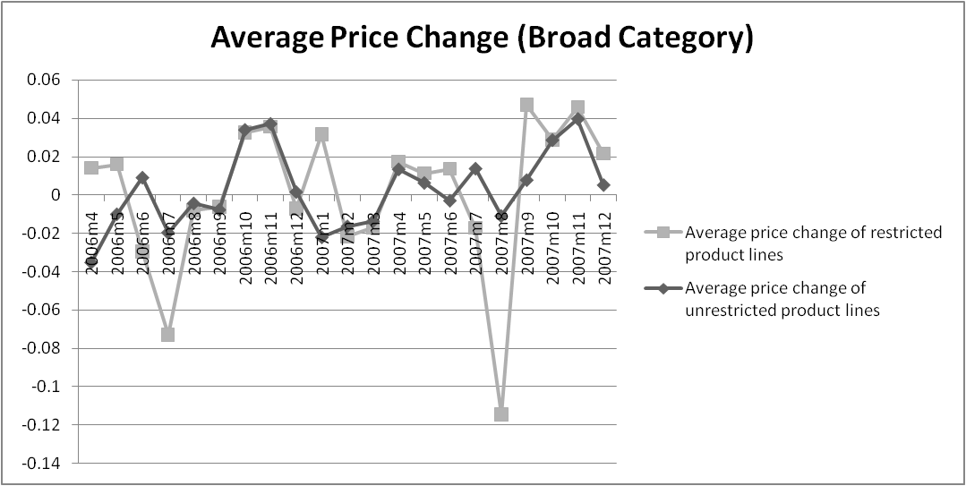

**Figure 1:** Average price change over the period of both restricted product lines and unrestricted product lines.

Notes: Unrestricted product lines include all other product lines upon which the quotas were not imposed.

While this is what theory predicts, the result was short lived. Looking at figure 2 the difference in price changes does not emerge when the broad unrestricted category is replaced by the matched unrestricted category. Instead the matched group tends to closely follow the erratic path of the restricted product lines indicating very little difference in average price changes for the restricted product lines relative to the unrestricted product lines over the period. These results suggest that any price increase expected from the quantitative restriction on clothing and textile from China was not felt by the consumers.

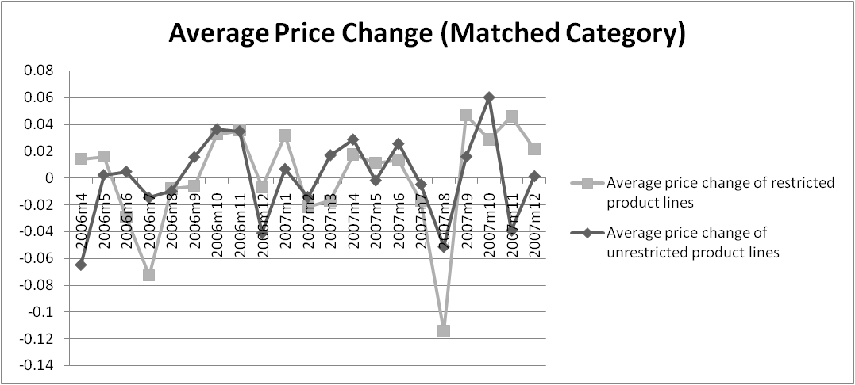

**Figure 2:** Average price change over the period of both restricted and unrestricted product lines.

Notes: Unrestricted product lines are matched to their quota-counterparts.

In order to investigate these descriptive results further we disaggregate the data and investigate the effects of the quota at the outlet level. Once again a treatment group and a control group are used for comparison; the price effects of the quota restricted goods are compared to those of the unrestricted goods.

Table 2 gives a description of the data at an outlet level. The table includes information regarding the average number of products held in the stores, the proportion of quota restricted products held, as well as the average price change of the quota restricted products (relative to unrestricted products). If stores moved away from stocking the restricted products we would expect to see a decline in the number of restricted products post-implementation (after January).

The results however do not support this expectation. Table 2 shows that the number of products held by outlets began falling towards the end of the year (before the implementation) with no notable changes from then onwards. Further, we note that the proportion of goods that were to be restricted did not decrease post-quota but stayed at around 18 percent for the entire 22 month period (56 percent when using the matched category dummy). Thus any changes in the number of products held by stores are unlikely to be due to changes in the proportion of quota restricted goods.

As mentioned, once the quota was implemented we would expect to see a decrease in the proportion of quota restricted goods held by stores. We would also expect to find an increase in the price of these goods. Referring again to table 2 we do not see such results, particularly in January 2007 and February 2007. The average price change of quota restricted goods relative to unrestricted goods remained unchanged at around negative 1 percent for the entire period. The proportion of quota restricted goods held against unrestricted goods also exhibits no noticeable change and, as previously mentioned, remained at a level of around 18 percent.

**Table 2:** Outlet Characteristics Before and After the Imposition of the Quota.



**Notes**: ⁺ Quota compared to broad non-quota category, ⁺⁺ Quota compared to specific non-quota category.

The results presented so far indicate that consumers were left unaffected by the quota. These results, whilst interesting, are descriptive and do not say anything about the significance of the findings. In order to evaluate the results at an analytical level, equation (1) was estimated in a number of different ways. The full regression results of these estimations are given in tables 2.1A to 5A in the Appendix. For ease of use, summary tables are provided in text.

Table 3 below gives the regression results for the average price effect of the quantitative restriction. The first regression in table 3 (column (1)) estimated the average monthly price change of the restricted product lines relative to the unrestricted product lines over the whole 22 month period (pre- and post-quota). The results indicate that relative to the unrestricted goods, the restricted goods experienced a positive, but insignificant, average price change of 0.05 percent. The second regression estimated the price effect of imposing the quota on the restricted product lines. As can be seen in column (2) the average prices of the restricted goods after imposition of the quota saw an increase of 0.3 percent relative to the prices before the quota, although this was not significant.

**Table 3:** Summary Results of Consumer Level Regressions on Average Price Change (Broad Category)



**Notes:** Standard errors are in parenthesis and *** p<0.01, ** p<0.05, * p<0. For the full regression results refer to table 2.1A in the Appendix.

The third column of table 3 shows the estimates from a regression which includes dummy variables for restricted lines before the quota, unrestricted lines before the quota and unrestricted lines after the quota. This specification allows us to evaluate the effects of the quota on the restricted goods compared to the unrestricted goods. The results show that after the implementation of the quota, unrestricted goods experienced an increase in average prices of 0.4 percent relative to the restricted goods.

When we included time dummies, in order to control for possible monthly (seasonal) differences in prices, the above results do not hold. As can be seen in columns (4) to (6) relative to the unrestricted goods over the whole period, restricted goods experienced an average price decrease of 0.6 percent; the average prices of restricted goods post-quota relative to the restricted goods pre-quota decreased by 0.5 percent; and the average prices of unrestricted goods post-quota relative to the restricted goods post-quota decreased by 0.7 percent. None of the above results are significant.

Table 4 below, gives the results for the same set of regressions with the exception that the broad unrestricted category is replaced by the matched category. The results are the same for the first two regressions in table 3 (including columns (4) and (5)). However, when comparing the effects of the quota on the restricted goods relative to the unrestricted goods, the results indicate that the average price change of the unrestricted goods post-quota relative to the restricted goods post-quota was a positive 0.2 percent without time fixed effects and a positive 0.04 percent with time effects. Once again, these results are not significant at a one percent, five percent or 10 percent level.

**Table 4:** Summary Results of Consumer Level Regressions on Average Price Change (Matched Category)



**Notes:** Standard errors are in parenthesis and *** p<0.01, ** p<0.05, * p<0. For the full regression results refer to table 2.2A in the Appendix.

Tables 5 and 6 repeat the above analysis for the broad unrestricted category and matched category respectively. The difference though is that these regressions investigate the standard deviation of the average price change instead of the average price change itself. The results show that the standard deviations of the price change of the restricted product lines over the whole period was a significant 0.314. This declined to 0.243 when taking into account the actual imposition of the quota. These results are similar when including the month controls. This could suggest that the standard deviations of the restricted group have decreased significantly after the quota. One possible explanation for this finding is that after the imposition of the quota, the lower section of the distribution of prices was “chopped off”. However, when we use the matched category these results are no longer significant.

**Table 5:** Summary Results of Consumer Level Regressions on Standard Deviation (Broad Category)



**Notes:** Standard errors are in parenthesis and *** p<0.01, ** p<0.05, * p<0. For the full regression results refer to table 3.1A in the Appendix.

**Table 6:** Summary Results of Consumer Level Regressions on Standard Deviation (Matched Category)



**Notes:** Standard errors are in parenthesis and *** p<0.01, ** p<0.05, * p<0. For the full regression results refer to table 3.2A in the Appendix.

Overall we have found no consistent, significant evidence to suggest that the quota increased prices at the consumer level. This supports our initial findings from figures 1 and 2 discussed previously. However, we have yet to control for omitted variables that differ from store to store but remain unchanged over time. We assume that there may be other characteristics that are different among stores but constant over time, for example store specific mark-ups or seasonal sales, that are not included in the model but influence the average prices. We thus move from product-line data to actual product x outlet data.

These store fixed effects are reported in the set of regressions in table 7 and 8 for broad and matched categories respectively. As reported in table 7, the restricted product lines experienced a significant decrease in average prices of 1 percent after the quota relative to before the quota. This result became insignificant once the store fixed effects were taken into account (see column (8)). The unrestricted product lines experienced a significant average price decrease of 0.8 percent relative to the restricted lines after the quota was implemented, but once again this result became insignificant after including store fixed effects.

**Table 7:** Summary Results for Individual Stores/Outlets – Price Level Data (Broad Category)



**Notes:** Standard errors are in parenthesis and *** p<0.01, ** p<0.05, * p<0. For the full regression results refer to table 4.1A in the Appendix.

The results in table 8 below differ from the above only in that the average price change of the unrestricted lines relative to the restricted lines post quota was a negative and significant 0.7 percent. This negative and significant result held even when the store fixed effects were included (see column (9)). These results suggest that the better (more robust) control group to use is the matched unrestricted group rather than the broad group. The broad category may be just too all-encompassing to be used as a comparison group. These results from table 7 and 8 also indicate that even by including store fixed effects we find no significant support for the hypothesis that the quota increased consumer prices.

**Table 8:** Summary Results for Individual Stores/Outlets – Price Level Data (Matched Category)



**Notes:** Standard errors are in parenthesis and *** p<0.01, ** p<0.05, * p<0. For the full regression results refer to table 4.2A in the Appendix.

So far the analysis of the price changes have been done over one period, i.e. month by month price changes. Our final set of set of regressions for the consumer level data investigates whether the prices of the restricted goods change significantly when analysed over longer time periods.

The results for this set of regressions are given in table 9, once again for both the broad and matched unrestricted categories. The first column represents the month by month changes; the second column represents quarterly changes; the third column half-yearly changes; and the fourth column annual changes.

Theory predicts that we would expect to see substantial price increases post quota (from January 2007 onwards). Referring to the first column it can be seen that relative to unrestricted goods, the quota restricted goods had a 0.2 percent higher average price change in January 2007 and a 0.4 percent higher average price change in February 2007. However, the results are not significant and when the broad unrestricted control is replaced by the matched unrestricted control the results are reversed.

**Table 9:** Summary Regression Results for Price Changes over Longer Lags



**Notes:** Standard errors are in parenthesis and *** p<0.01, ** p<0.05, * p<0. For the full regression results refer to table 5A in the Appendix.

The table also shows us that three months after the imposition of the quota (April 2007), prices of the restricted goods saw an increase of 0.4. However, this result is not significant or robust; when the matched category was used as the control the price change became negative and insignificant. Further analysis of this table provides no additional significant information; regardless of the lag length we can find no significant, persistent increase in prices.

Overall, one can see that although prices on the restricted goods were expected to increase, there is no statistical evidence in the consumer prices to support this hypothesis. Even after controlling for time and store fixed effects, these regressions support our earlier findings that there was no significant effect on prices as a result of the quantitative restriction at the consumer level.

There are a number of possible explanations for these results. The first explanation lies with the data. More specifically, when capturing the product lines and their various HS codes, it may be that the quota lines were not completely matched. This is a result of the different classification system used in the collection of consumer prices compared to the HS codes used to denote quota lines. Whilst this is of concern, it is not one which is easily identifiable. The second explanation could be that the suppliers of the quota restricted goods absorbed the price increases associated with the quota. This explanation is not one which we are able to explore with our data.

Another possible explanation for why prices were left unchanged is that South African producers may have increased production in order to fill the gap left by the quota. As such, consumers would not be left with higher prices as a result of restricted supply. However figures 3 and 4 below show that as the date of implementation approached local production of textiles and wearing apparel decreased as the period of implementation neared, this suggests that local producers did not raise their level of output to fill the gap.

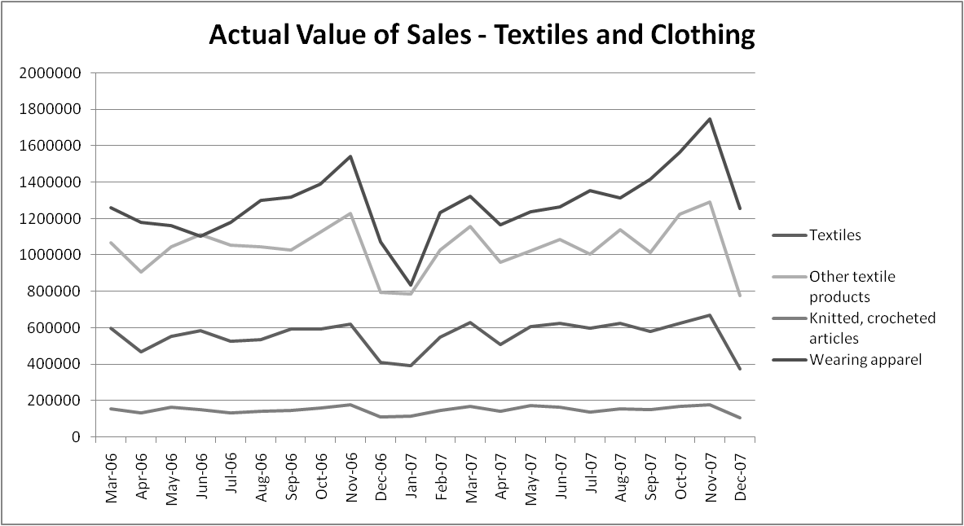

**Figure 3**: Actual Value of Sales in ZAR 1000

Data: Statistics South Africa

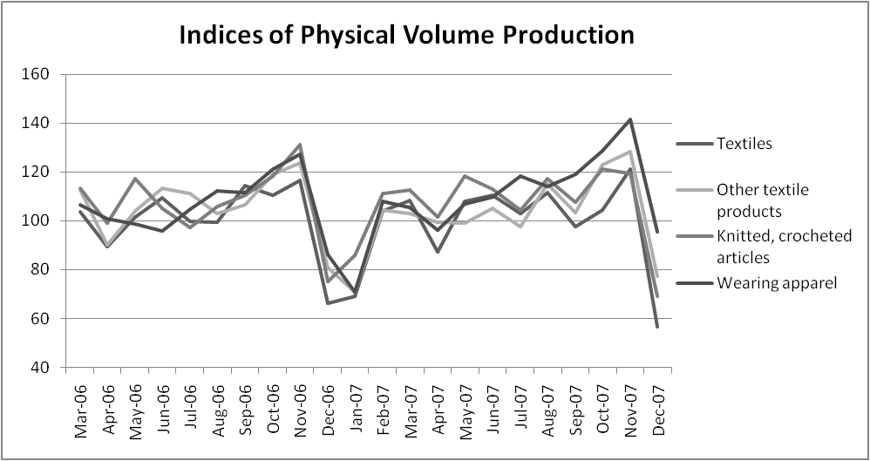

**Figure 4**: Index of Phyiscal Production Volume, 2005=100

Data: Statistics South Africa

A further possible explanation is the possibility that South African producers used the quota as an excuse to increase the price of goods in both the restricted and unrestricted lines. The table below compares the monthly local price changes in 2006 with that of 2007. The decision to implement the quota was announced in September of 2006. If local producers did indeed use this as an opportunity to increase the price on all goods we would anticipate the price changes in the last few months of 2006 to be greater than that for the same period in 2007. However in 2006 prices increased by 0.6 percent from September to October whilst for the same period in 2007 prices increased by 0.8 percent as shown in table 10. This suggests that South African producers did not take advantage of the quota to increase the prices of all goods.

**Table 10:** Monthly Local Price Changes of Textile and Clothing Products.



**Notes:** Standard errors are in parenthesis and *** p<0.01, ** p<0.05, * p<0.1

There are however two additional explanations which we are able to investigate further. Firstly, it may simply be the case that the quota was not binding. As the results below will show, given that the volume of imports from China in the restricted product lines did actually decrease post quota this would suggest that the quota was binding. In order to confirm this fully we would need to show that the reduction in imports equalled the quota amount. Again we are unable to fully exploit this fact with our data. This leads to the final possible explanation; perhaps it was the case that the South African importers shifted their demand towards other low cost, unrestricted producers. As a result there was no need to increase the prices charged to consumers.

**5.2 Landed Price/ Trade Level Data**

In order to investigate the arguments in the preceding paragraph, data on the landed prices of the quota restricted and unrestricted products must be analysed. Both the trade value and the trade volume are examined for the period 2005 to 2009 and the results of this trade level analysis are presented below.

Figure 5 illustrates the pattern of imports from China into South Africa. Over the five year period imports of unrestricted products remained fairly unchanged. Despite this the value of quota restricted imports from China saw a sudden decrease from the end of 2006 once the quota was implemented. Further, once the restriction had been removed at the end of 2008 the value of the previously restricted goods increased.

It may be argued that these results are simply illustrative of the trade pattern of such goods in general over the period. However, a view of the South African import market over the period 2005 to 2009 does not support this argument. Figure 6 illustrates a relatively consistent inflow of quota restricted and unrestricted products into South Africa from all countries. This suggests that the market for imports was fairly stable and there is little evidence of a slowing down of trade towards the end of 2006 or a recovery in the latter years. It is therefore likely that the change in the values of quota constrained imports from China was as a result of trade policy intervention.

**Figure 5:** Trade Value of South African Imports of Clothing and Textiles from China Pre- and Post-Quota.

Data: World Integrated Trade System (WITS).

**Figure 6:** Trade Value of South African Imports of Clothing and Textiles from All Countries Pre- and Post-Quota.

Data: World Integrated Trade System (WITS).

Table 11 and 12 give further support of decreasing trade values from China. Table 11 contains information on the amount of total imports of clothing and textile product lines flowing into South Africa from its top 15 trade partners in these product lines (in terms of import trade value). Table 12 contains information on only the quota restricted imports flowing into South Africa from the same 15 countries. The trade value and percentage change in trade value over the period 2005 to 2009 are presented in both tables. Of interest is the period when the quota was implemented, beginning of 2007, and 2009 when it was removed. According to theory one would expect to see a reduction of imports from China in 2007 and an increase in 2009.

Table 11 shows that at the time of the quota implementation imports of both restricted and unrestricted goods were increasing from 13 of the 15 countries. China was one of the two countries that experienced a decrease. Total imports from China decreased by 4.53 percent in 2007 in terms of trade value. In 2009 total imports from China had increased by 6.45 percent.

These changes were almost certainly as a result of the changes in restricted imports. This is supported by evidence in table 4. In 2007 the amount of quota restricted imports from China decreased by 46.02 percent followed by a further 4.79 percent decrease in 2008. In 2009 the total decrease of imports from China was almost fully recovered as imports increased by 45.62 percent. These results are what theory predicted and give further support against the argument that the reduction of imports from China was as a result of a reduction in overall trade.

**Table 11:** Sources of South African Imports of both Restricted and Unrestricted Goods, 2005 to 2009



**Notes:** Trade Value in South African rand. *(compared to 2005), ** (compared to 2006), *** (compared to 2007), **** (compared to 2008)

**Table 12:** Sources of South African Imports of Restricted Goods, 2005 to 2009.



**Notes:** Trade Value in South African rand. *(compared to 2005), ** (compared to 2006), *** (compared to 2007), **** (compared to 2008)

The most likely explanation for why consumer prices were unaffected by the quota is that South African importers compensated for the decline in imports from China by shifting to imports from other low cost countries. From table 12 one can see the countries that showed the most noticeable increase in quota restricted exports to South Africa in 2007. This group includes Bangladesh, Indonesia, Mauritius and Vietnam who saw an increase in value of 230 percent, 158 percent, 95 percent and 412 percent respectively. This table further illustrates how imports from these countries decreased in 2009 once the restriction was removed. However, this reduction in imports from these four substitutes was not large considering the levels by which the values initially increased. This could result in local producers being faced with even more competition once the restriction on the Chinese imports was dropped.

A graphical illustration of these four alternative import sources shows that there was undoubtedly an increase in the amount of quota restricted imports from these destinations once the quota was implemented as well as a reduction once it was removed (figure 7). Increased imports from these producers has resulted in the overall level of South African imports of clothing and textiles within the quota restricted lines remaining mostly unchanged since before the start of the trade intervention.

**Figure 7:** Trade Value of South African imports of quota restricted product lines from Bangladesh, Indonesia, Mauritius and Vietnam, 2005 to 2009.

Data: World Integrated Trade System (WITS).

The preceding results are for the trade value of imports. These changes in trade value could be comprised of changes in either quantity or price or both. The quota imposed by the South African Government was a restriction on the physical quantity of imports. Therefore, one would expect that the value effect that was previously discussed was a combination of a reduction in the quantity of imports as well as an increase in the prices of the quota restricted lines from China. We reproduce the tables and figures above using the change in trade volume (physical quantity) to show the effect of the quota on the quantity of imports.

Figure 8 shows how the physical quantity of quota restricted imports from China decreased at the start of the quota regime and increased afterwards whilst the year-on-year change in unrestricted imports was positive except for 2009. The quota was therefore successful in reducing the physical amount of textiles and clothing imports from China. Figure 9 illustrates the effect of the quota on the change in prices of imports from China. As was expected, the change in price of quota restricted imports saw a large increase as soon as the quota was imposed, indicating potential quality upgrading. However these change in prices decreased soon after and continued to decrease once the quota was removed.

**Figure 8:** Percentage Change in Quantity of Clothing and Textile Imports from China, 2005 to 2009.

Data: World Integrated Trade System (WITS).

**Figure 9:** Percentage Change in Price of Clothing and Textile Imports from China, 2005 to 2009.

Data: Word Integrated Trade System (WITS)

Table 13 shows the quantity effect of the quota on overall South African imports from the top 15 trade partners. These countries are the same countries used in the previous analysis for comparative purposes. Table 14 shows the results for the quota restricted imports only. These tables give evidence in support of the previous results. The physical quantity of imports from China fell over the implementation period, particularly in the quota restricted lines which experienced a 71 percent decline in 2007 and a 127 percent increase in 2009.

**Table 13:** Percentage Change in Quantity of South African Imports of both Restricted and Unrestricted Goods from the Top 15 Trade Partners, 2005 to 2009.



**Notes :**\*( compared to 2005), ** (compared to 2006), *** (compared to 2007), **** (compared to 2008)

**Table 14:** Percentage Change in Quantity of South African Imports of Restricted Goods from the Top 15 Trade Partners, 2005 to 2009.



**Notes**: *(compared to 2005), ** (compared to 2006), *** (compared to 2007), **** (compared to 2008)

The substitution outcome is also evident in terms of trade volume. Once again the countries that indicated the most pronounced increase in the quantity of restricted product lines in 2007 were Bangladesh, Indonesia, Mauritius and Vietnam. A graphical illustration is presented below which supports this statement (figure 10). As can be seen there was a dramtic an increase in the amount imported from these countries after the implementation of the quota (from the end of 2006). There therefore exists evidence both in terms of trade value and trade volume that shows a reduction in the amount imported from China as well as the shift of imports towards other low cost producers.

**Figure 10:** Percentage Change in the Quantity of South African imports of restricted clothing and textiles from Bangladesh, Indonesia, Mauritius and Vietnam, 2005 to 2009.

Data: World Integrated Trade System (WITS).

The descriptive analysis of the trade level data has shown that China experienced a decrease in trade volumes after the start of the quota regime which was a combination of a decrease in trade volume and an increase in prices. This result is consistent with trade theory and is suggestive of quality upgrading. At the same time there is evidence that South African importers shifted towards other low cost producers. The results also show what one would expect post-quota.

The next step is to investigate whether there was indeed significant quality upgrading and substitution. In order to test these findings at an analytical level, equations (3) and (4) are estimated for the different dependant variables as discussed in section 5. This is the less restrictive specification. The trade level regressions investigate the effects of the quantitative restriction on import values, volumes and prices from China as well as the potential substitute countries discussed above. The results of these regressions are given in table 15 which examines the effect immediately after implementation and table 16 which examines the effect of removing the restriction.

The first regression, represented in column (1), investigates the marginal impact on the trade value of imports from China on quota restricted products using all other countries as the control group. The interaction coefficient on “China Interaction Dummy” essentially tells us the marginal effect on quota restricted products relative to non-quota restricted products from China relative to all other countries relative to pre-implementation. Similarly the interaction coefficient on “SADC Interaction Dummy” essentially tells us the marginal effect on quota restricted products relative to non-quota restricted products from SADC relative to all other countries, and so on for the other countries.

The second regression, represented by column (2), uses alternative controls to test whether there has been substitution to different regions (such as SADC, Bangladesh, Indonesia, Mauritius and Vietnam).Columns (3) and (4) do the same but investigate the effects on volumes, whilst columns (5) and (6) investigate the effects on prices.

As can be seen from the regression results in column (1) of table 15 below the marginal impact on imports from China of quota restricted products was a significant 56 percent decrease in trade value. On the other hand we note a substantial and significant increase in the trade value of quota restricted imports from the competitor countries relative to all other countries excluding China (Column (2)). Bangladesh experienced a 268 percent increase in trade value whilst Vietnam experienced a 257 percent increase. Indonesia and Mauritius saw increases of 99 percent and 106 percent respectively. These results confirm the findings of the descriptive analysis and indicate that substitution did indeed occur.

**Table 15: Regression Results at the Trade Level – post-implementation**



**Notes:** Standard errors are in parenthesis and *** p<0.01, ** p<0.05, * p<0.1. Estimates are in natural logarithms

**Table 16: Regression Results at the Trade Level – post-quota**



**Notes:** Standard errors are in parenthesis and *** p<0.01, ** p<0.05, * p<0.1. Estimates are in natural logarithms

Table 16 gives us the results of the end of the quota. Column (1) indicates that the marginal impact on imports of quota restricted products from China was a significant 103 percent increase in trade value. The substitute countries experienced a significant decrease in trade value post-quota, however as previously shown these decreases were not as considerable as the initial increases suggesting that South African producers now have more competitors to contend with than before the quota.

These outcomes are further supported when investigating the quantity effect. As can be seen in columns (3) and (4), we find a considerable decline in import quantities in the quota restricted lines from China of 71 percent (after implementation) and a 166 percent increase in the same lines once the restrictions against China were removed. . The competitor countries experienced a significantly large increase in import volumes in 2007 and a relatively slight decrease in volumes in 2009. For example, Bangladesh experienced an increase in the volumes of quota restricted imports, relative to unrestricted imports, of 343 percent in 2007. In 2009 Bangladesh had reduced the quantity exported of these products to South Africa by only 22 percent.

In both instances the (absolute) quantity effect is much larger than the (absolute) value effect. This suggests that China has shifted imports towards more expensive varieties whilst the competitor countries have shifted towards less expensive varieties as a result of the quota.

The regression results in columns (5) and (6) of table 15 confirm this suggestion. These regressions investigate the effect of the quota on import prices. The change in prices is used as a proxy for changes in quality. These results indicate that the effect of the quota on the prices of quota restricted products from China was a significant 43 percent increase. This could reflect price increases of existing products, as well as shifts in the composition of imports towards higher priced, and thus higher quality, varieties within the quota restricted categories. These results are reversed in table 16 with prices of Chinese imports decreasing by 19 percent. However as previously mentioned it is important to note that for now this conclusion is based on the use of price as a proxy for quality changes. Further research will need to be done which uses price and quality indices proposed by Feenstra (1995) in order to separate out the pure price effect and the precise quality effect of the quota.

When the comparator countries are included in the regression we note significant declines in import prices from SADC, Vietnam and Indonesia immediately after the imposition of the quota and an increase in these prices once the quota regime ended. This suggests a shift towards less expensive varieties, i.e. low quality varieties are being imported from these countries in response to the quantitative restriction on Chinese clothing and textiles.

Overall the trade data gives evidence not only of substitution, but also quality upgrading of imports from China and quality downgrading of imports from other low cost competitors during the quota implementation period. The fact that South African importers compensated for the large decline in imports from China by increasing imports from other low cost countries provides an explanation for why consumer prices remained unchanged despite the quantitative restriction.

**6. Concluding Remarks**

This paper investigates the effects of the quotas imposed, by South Africa, on imports of Chinese clothing and textile products in January 2007. Specifically, it is the first attempt to quantify the impact of these quotas on the prices that consumers actually pay for products that fall within the quota constrained product lines. Restrictions in the quantity of goods imported from a specific country may raise consumer prices if there are no close substitutes, at similar prices, from other non-quota restricted countries, and if, increases in landed prices are passed on to consumers.

In order to investigate whether the quotas impacted on consumer prices we use a unique micro-dataset. This dataset comprises of prices collected at the product and store level and is collected by Statistics South Africa in order to calculate the Consumer Price Index. To identify price effects we compare price changes between the quota-restricted products and two other groups of products – all other products in the clothes and textiles category and a basket of matched similar products – using a difference-in-differences estimation strategy. Our findings suggest that there was no change in relative prices of quota restricted goods compared to other clothing and textile products or to the basket of similar matched products.

We investigate a number of reasons why this may be the case. We present evidence that indicates that the most likely reason is that South African importers shifted to other countries that produced these products at similar prices. Disaggregated trade data indicates that the quotas were indeed successful in reducing the amounts imported from China. Both the trade value and volume of Chinese imports in the restricted product lines were reduced. However, there was a significant concomitant increase in the amount imported from other low-cost producers such as Bangladesh, Indonesia, Mauritius and Vietnam. The increased imports from these producers meant that total imports of clothing and textile within the restricted lines remained at a similar level to what they were before the quota was implemented. Perversely, the quotas may have helped clothing producers in other SADC countries since it seems that imports from these countries reduced in quality during the quota period. Unlike other countries which filled the space created by the quotas, SADC imports were the only group of imports, apart from China, that increased in value after the quotas ended.

The stated aim of the quotas was to aid domestic producers. An alternative explanation for the observed lack of a change in prices may have been due to a local producer response. It is possible that the South African producers either increased production in order to close the gap left by the quota or used the quota as an excuse to increase the prices of all products. However, our analysis indicates that neither of these explanations hold.

Lastly we examine whether the quality of the products imported from China in the restricted product lines change. Theory and empirical evidence from other countries suggest that quotas lead to quality upgrading for the restricted goods. Using price as a proxy for quality we find that the prices of the restricted lines from China increased after the quota was imposed and decreased for the substitute countries. The results suggest that there may have been quality upgrading within the quota restricted product lines from China and quality downgrading from the substitute countries. We do not distinguish whether these price increases were as a result of quality shifts within the restricted categories or whether it was simply increases in the price of existing products.

This paper shows that the imposition of these quotas was ineffectual. South African producers did not increase production and South African importers merely switched to other low-cost non-quota restricted countries. As a result of this South African consumers did not experience price increases. This suggests that quotas are the wrong policy to use for limiting import competition if close substitutes for the quota goods exist that are produced in other non-quota restricted countries.

# References

Anderson, J. E. (1991). The Coefficient of Trade Utilization: the Cheese Case. In R. E. Baldwin, *Empirical Studies of Commercial Policy* (pp. 221-244). Chicago: University of Chicago Press.

Aw, B. Y., & Roberts, M. J. (1986). Measuring the Quality Change in Quota-Constrained Import Markets. *Journal of International Economics* , 45-60.

Bhagwati, J. N., Panagariya, A., & Srinivasan, T. N. (1998). *Lectures on International Trade* (2nd ed.). Cambridge, Mass.: The MIT Press.

Biacuana, G. (2009). SA's Clothing and Textile Sector post 'Chinese Quotas'. *South African Institute of International Affairs (August)* .

Boorstein, R., & Feenstra, R. C. (1991). Quality Upgrading and Its Welfare Cost in U.S. Steel Imports, 1969-74. *International Trade and Trade Policy* , 167-186.

Brambilla, I., Khandelwal, A., & Schott, P. (2007). China's Experience under the Multifibre Arrangement (MFA) and the Agreement on Textiles and Clothing (ATC). *NBER working paper 13346* .

Brink, G. (2006). *The Memorandum of Understanding and Quotas on Clothing and Textile Imports from China: Who Wins?* Tralac working paper no. 17/2006, Stellenbosch.

Cowen, T., & Tabarrok, A. (1995). Good Grapes and Bad Lobsters:Applying the Alchian and Allen Theorem. *Economic Inquiry* , 253-256.

Crandall, R. W. (1984). Import Quotas and the Automobile Industry: the Cost of Protectionism. *The Brookings Review* , 8-16.

Falvey, R. E. (1979). The Composition of Trade within Import-restricted Product Categories. *Journal of Political Economy* , 1105-1114.

Feenstra, R. C. (1988). Quality Change Under Trade Restraints in Japanese Autos. *The Quarterly Journal of Economics* , 131-146.

Fundira, T. (2007). *Update: South African Quotas on Chinese Clothing and Textiles: Has There Been Sufficient Economic Justification.* Tralac trade brief no. 09/2007.

Harrigan, J., & Barrows, G. (2006). Testing the Theory of Trade Policy: Evidence from the Abrupt End of the Multifibre Arrangement. *NBER working paper no. 12579* .

Herguera, I., Kajul, P., & Petrakis, E. (2000). Quantity Restrictions and Endogenous Quality Choice. *International Journal of Industrial Organization* , 1259–1277.

Krugman, P. R., & Obstfeld, M. (2006). *International Economics: Theory and Policy* (Seventh ed.). New York: Pearson Addison Wesley.

Leffler, K. B. (1982). Ambiguous Changes in Product Quality. *The American Economic Review* , 956-967.

Musgrave, A., & le Roux, M. (2006, September 11). South Africa: 'Treason' to avoid China quotas, retailers told. *Business Day (South Africa)* .

Naude, W., & Rossouw, R. (2008). South African Quotas on Textile Imports from China: A policy error? *Journal of Policy Modeling* , 737–750.

Rodriguez, C. A. (1979). The Quality of Imports and the Differential Welfare Effects of Tariffs, Quotas, and Quality Controls as Protective Devices. *The Canadian Journal of Economics* , 439-449.

Sandrey, R. (2006). *The Trade and Economic Implications of the South African Restrictions Regime on Imports of Clothing from China.* Tralac Working paper no. 16/2007, Stellenbosch.

Sandrey, R., & Fundira, T. (2008). *Quota Imports of Chinese Clothing into South Africa: the First Year Analysis.* Tralac trade brief no. 04/2008.

Santoni, G. J., & Van Cott, N. T. (1980). The Quality Adjustment Problem. *Southern Economic Journal* , 1206-1211.

SARS. (2006). *Memorandum of understanding between the Government of the Republic of South Africa and te Government of the Peoples Republic of China on Promoting Bilateral Trade and EConomic Cooperation.* Pretoria: Government Gazette No. 29185 .

Van Eeden, J. (2009). *South African Quotas on Chinese Clothing and Textiles – Economic Evidence.* Econex Research Note 9, retrieved from www.econex.co.za on 9 June 2010.

Van Eeden, J., & Fundira, T. (2008). *South African Quotas on Chinese Clothing and Textiles: 18 Month Economic Review.* Tralac working paper no. 08/2008, Stellenbosch.

Van Eeden, J., & Sandrey, R. (2007). *South African Quotas on Chinese Clothing and Textiles: Has There Been Sufficient Economic Justification?* Tralac trade brief no.06/2007.

Vlok, E. (2006). The Textile and Clothing Industry in South Africa. In H. Jauch & R. Traub-Merz (Eds.). *The future of the textile and clothing industry in sub-Saharan Africa* , Bonn: Friedrich-Ebert Stiftung, 227-246.

**APPENDIX**

**Table 1:** Import quotas (2007–2008) of 31 tariff lines of Chinese exports into South Africa



**Source:** Government Gazette 29185.

**Table 2.1A: Consumer Level Regression Results on Average Price Change (Broad Category)**



**Notes:** Standard errors are in parenthesis and *** p<0.01, ** p<0.05, * p<0.1

**Table 2.2A: Consumer Level Regression Results on Average Price Change (Matched Category)**



**Notes:** Standard errors are in parenthesis and *** p<0.01, ** p<0.05, * p<0.1

**Table 3.1A: Consumer Level Regression Results on Standard Deviation (Broad Category)**



**Notes:** Standard errors are in parenthesis and *** p<0.01, ** p<0.05, * p<0.1

**Table 3.2A: Consumer Level Regression Results on Standard Deviation (Matched Category)**



**Notes:** Standard errors are in parenthesis and *** p<0.01, ** p<0.05, * p<0.1

**Table 4.1A: Regression Results for Individual Stores/Outlets – Price Level Data (Broad Category)**



**Notes:** Standard errors are in parenthesis and *** p<0.01, ** p<0.05, * p<0.1

**Table 4.2A: Regression Results for Individual Stores/Outlets – Price Level Data (Matched Category)**

**Notes:** Standard errors are in parenthesis and *** p<0.01, ** p<0.05, * p<0.1

**Table 5A: Regression Results for Price Changes over Longer Lags**



**Notes:** Standard errors are in parenthesis and *** p<0.01, ** p<0.05, * p<0.1